Format to report your ADVANCED JAVA PROGRAMMING PROJECTS

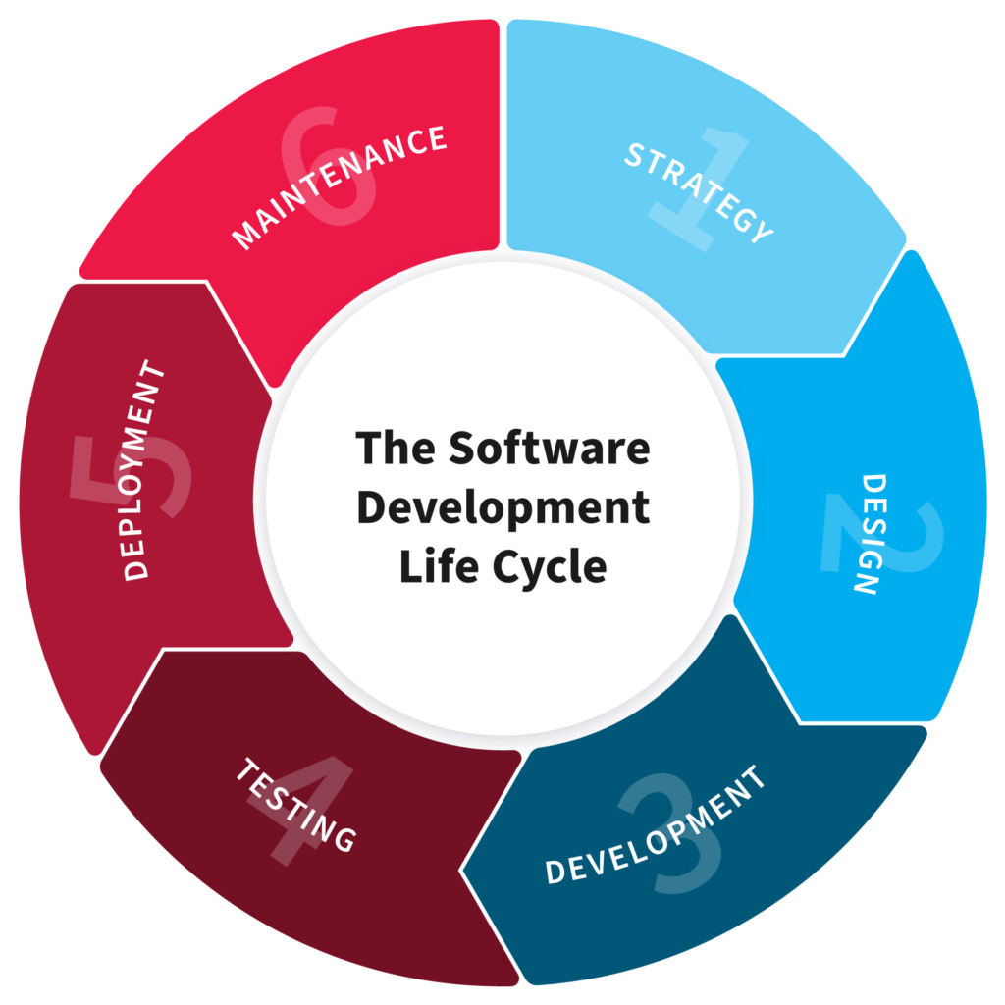

NAME: KARAKE Omar
REG NO: 221022092
CLASS NO: Group 2

PROJECT NAME: Hotel management System

1.PLANNING

“In this Section, Students, have to define the system (your projects) goals and objectives and the problems the future system needs to solve.”

What does a hotel business need to survive in a competitive market?
At least two things: Have an online presence that makes the reservation process easier
and deliver outstanding customer service so that visitors returning to your area will
choose your location again. Automating daily operations and administrative tasks is an
important part of achieving customer satisfaction as it helps provide reliable and
quality service time after time.

A hotel is a complex system that encompasses the activities of many departments, and
every operation must be tracked. For this purpose, hoteliers utilize various tools
including spreadsheets, paper forms, and unified Hotel management systems.

We going to build hotel management systems (HMSs) that handle reservations,
front- and back-office operations, channel management, and more.
You’ll learn about the main functions of HMSs.

What is a hotel management system?
A Hotel management system (HMS) is software that facilitates a hotel’s reservation
management. The most important functions include front-desk
operations, reservations, channel management, housekeeping, rate and occupancy
management, and payment processing. Although HMS software mostly controls reservation
and financial transactions, it may allow you to manage housekeeping and perform human
resources management as well. In general, HMS facilitates the main processes in a hotel
related to internal and external operations.

However, technology innovations have found their way into the hospitality industry. In 2015,
a report “Hotel Management Software BuyerView” by Software Advice showed that only 34 percent
of hotels used special software, while 25 percent still relied on pen and paper only to manage
their hotels, and 16 percent had no hotel management system at all. Today, according to the
Stayntouch 2022 Technology Sentiment Report, 81.7 percent of hotels have implemented at least
one type of technology during the pandemic.

Hoteliers started looking for innovative solutions such as self-service check-in, in-room
controls, mobile keys, and digital payments. Many big players have already implemented smart
technologies based on the Internet of Things infrastructure. But there are still a lot of
legacy systems in use.

Legacy HMS software may perform just one function, require additional modules, or be too hard
to integrate with other necessary hotel management software. Consequently, hotel owners are
looking for a universal, one-and-done solution to manage all the processes. Over 80 percent of
respondents to the 2022 Hotel Technology Survey reported that they want to learn more about technology.

Currently, hotel management systems are used by big hotel chains, small hostels, and
everything in between. With these systems, hotels can see the booking status of rooms and control
reservations. However, their functionality doesn’t end here. Via HMS, hoteliers can manage back-office
processes, food and beverage services, and track room occupancy rates.

Let’s take a closer look at
the most common functions supported by HMS.

Key functions of the reservation module include:

- Room bookings: The system checks room availability and status, shows free rooms across different channels and the website booking engine. This function monitors double bookings and allows group

- Reservations: Then it schedules bookings and displays information about current and upcoming
bookings on a dashboard.

- E-payments processing: Software collects online transactions and classifies them according to
their types and categories.

- Management of room inventory and allocation: Reservation tools prevent overbookings and double bookings. In some software, this function is part of a channel management module.

- Reservation emails: The system sends confirmations to guests after they complete their
booking. In some HMSs, this function is a part of the front-desk operations module.

- Activities booking: Some software allows guests to book not only accommodation but also
activities with this system.

2. Design

“In this Section, students’ needs to elaborate how the system will work, focusing on software design and how it works with the technical and functional requirements of the system. Depicts also how your team defined how users will interact with the software.”

System Requirements
Functional and non-functional criteria are the two types of requirements that the hotel management system must meet.

Functional Requirements
Booking / Reservation:

- Keep track of reservations.
- Keep track of the customer's first name.
- Keep track of the customer's last name.
- Keep track of the number of occupants.
- Keep track of the room number.
- Show the default room rate
- Make a note of the customer's phone number.
- Indicate whether the room is assured.
- Create a unique confirmation number for each transaction.
- Make a note of the anticipated check-in date and time.
- The system must keep track of the anticipated checkout date and time.
- Customers will be checked in by the system.
- The system must allow reservations to be changed without requiring the customer to resubmit all their information.
- Customers will be checked out by the system.

Use Case Diagram of Hotel Management System
This Use Case Diagram depicts the relationships between the pieces of the Hotel Management System graphically. It is the process used in system analysis to discover, clarify, and organize Hotel Management System requirements. The major components of the Hotel Management System UML use case diagram are depicted in the graphic below.

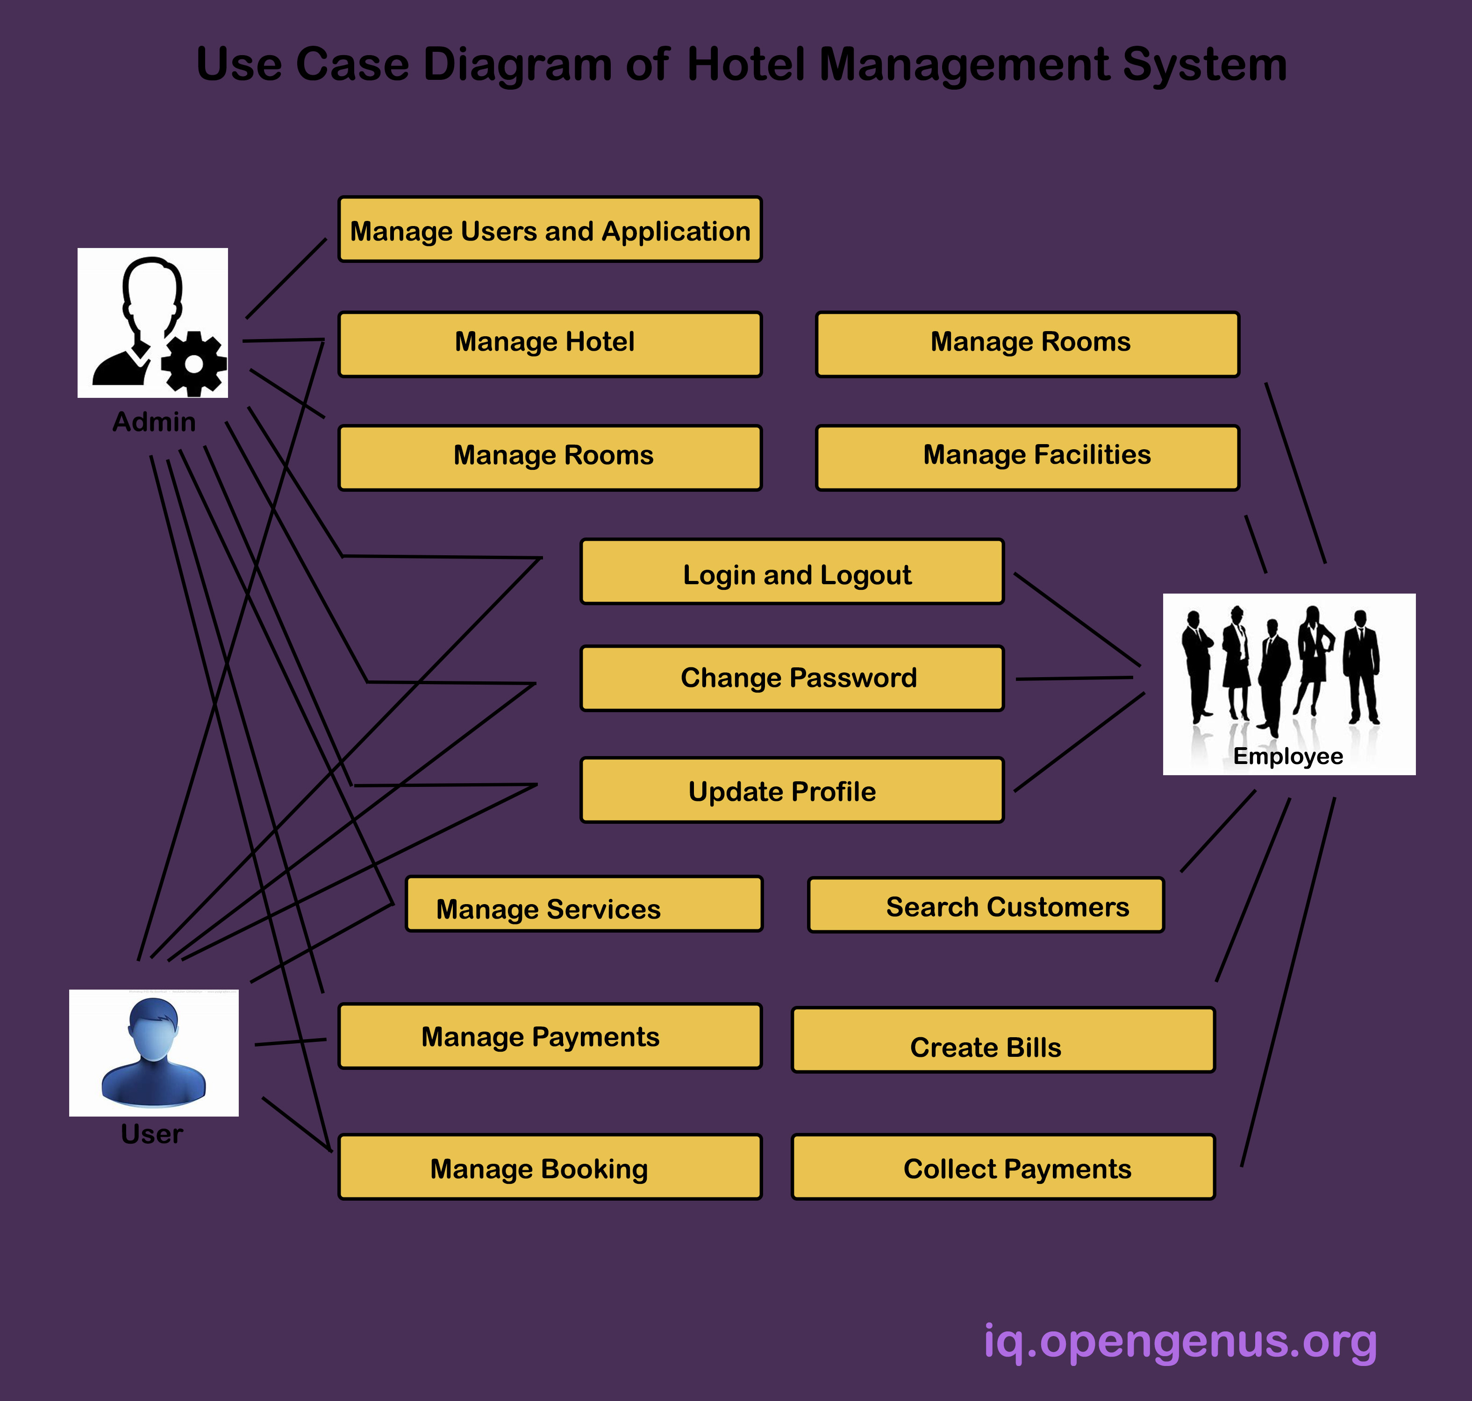

3. Development

“In this Section, Students need to elaborate how they build the entire system (Front end- back-end technologies), chosen libraries, platforms, storage and databases, adopted technologies, etc...”

To build this project we used java project and NetBeans IDE pc software application as text editor and jframes. Database we used is Xampp server, PHPmyadmin to record our data of our system and other library for dates we will provide website where we found other library we used that wasn’t built in the NetBeans IDE

Back-end and front end of hotel management system.

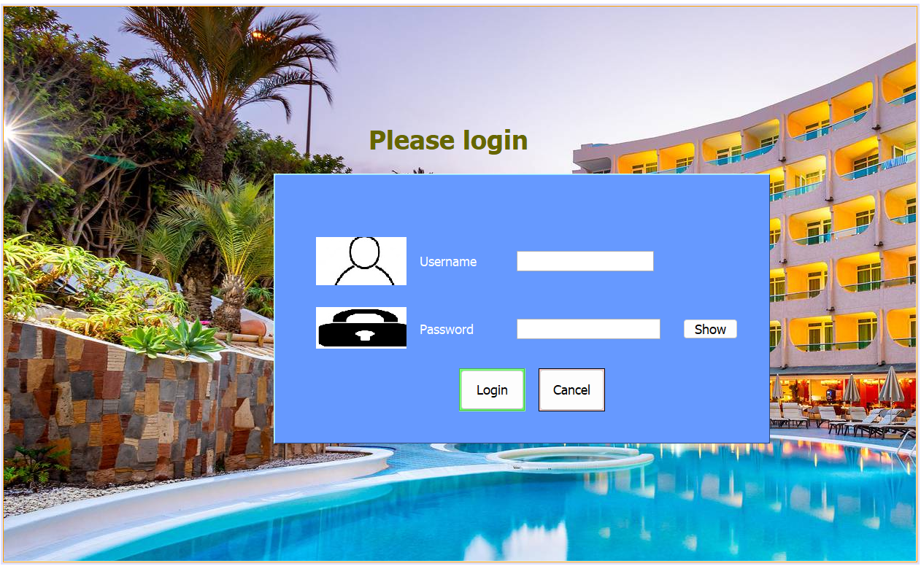
/*
* To change this license header, choose License Headers in Project Properties.
* To change this template file, choose Tools | Templates
* and open the template in the editor.
*/
package hotelmanagement;

import java.sql.Connection;
import java.sql.DriverManager;
import java.sql.PreparedStatement;
import java.sql.ResultSet;
import java.sql.SQLException;
import java.util.logging.Level;
import java.util.logging.Logger;
import javax.swing.JOptionPane;
import javax.swing.table.DefaultTableModel;

/**
*
* @author Omar
*/
public class login extends javax.swing.JFrame {

/**
* Creates new form login
*/
public login() {
initComponents();
connect();
}
Connection con;
PreparedStatement pst;
ResultSet rs;
public void connect(){
try {
Class.forName("com.mysql.jdbc.Driver");
con=DriverManager.getConnection("jdbc:mysql://localhost:3306/hotelmanagement", "root","");
} catch (ClassNotFoundException ex) {
Logger.getLogger(room.class.getName()).log(Level.SEVERE, null, ex);
} catch (SQLException ex) {
Logger.getLogger(room.class.getName()).log(Level.SEVERE, null, ex);
}
}

/**
* This method is called from within the constructor to initialize the form.
* WARNING: Do NOT modify this code. The content of this method is always
* regenerated by the Form Editor.
*/
@SuppressWarnings("unchecked")
// <editor-fold defaultstate="collapsed" desc="Generated Code">
private void initComponents() {

jLabel1 = new javax.swing.JLabel();
jPanel1 = new javax.swing.JPanel();
jLabel2 = new javax.swing.JLabel();
jLabel3 = new javax.swing.JLabel();
txtuname = new javax.swing.JTextField();
txtpass = new javax.swing.JPasswordField();
jButton1 = new javax.swing.JButton();
jButton2 = new javax.swing.JButton();
jToggleButton1 = new javax.swing.JToggleButton();
jLabel5 = new javax.swing.JLabel();
jLabel6 = new javax.swing.JLabel();
jLabel4 = new javax.swing.JLabel();

setDefaultCloseOperation(javax.swing.WindowConstants.EXIT_ON_CLOSE);
setBackground(new java.awt.Color(153, 153, 153));
setCursor(new java.awt.Cursor(java.awt.Cursor.DEFAULT_CURSOR));
getContentPane().setLayout(new org.netbeans.lib.awtextra.AbsoluteLayout());

jLabel1.setFont(new java.awt.Font("Tahoma", 1, 36)); // NOI18N
jLabel1.setForeground(new java.awt.Color(102, 102, 0));
jLabel1.setText("Please login");
getContentPane().add(jLabel1, new org.netbeans.lib.awtextra.AbsoluteConstraints(500, 160, 220, -1));

jPanel1.setBackground(new java.awt.Color(102, 153, 255));
jPanel1.setBorder(new javax.swing.border.SoftBevelBorder(javax.swing.border.BevelBorder.RAISED));

jLabel2.setFont(new java.awt.Font("Tahoma", 0, 18)); // NOI18N
jLabel2.setForeground(new java.awt.Color(255, 255, 255));
jLabel2.setText("Username");

jLabel3.setFont(new java.awt.Font("Tahoma", 0, 18)); // NOI18N
jLabel3.setForeground(new java.awt.Color(255, 255, 255));
jLabel3.setText("Password");

txtuname.setFont(new java.awt.Font("Tahoma", 0, 18)); // NOI18N

txtpass.setFont(new java.awt.Font("Tahoma", 0, 18)); // NOI18N

jButton1.setBackground(new java.awt.Color(102, 255, 102));
jButton1.setFont(new java.awt.Font("Tahoma", 0, 18)); // NOI18N
jButton1.setText("Login");
jButton1.setBorder(javax.swing.BorderFactory.createEtchedBorder());
jButton1.addActionListener(new java.awt.event.ActionListener() {
public void actionPerformed(java.awt.event.ActionEvent evt) {
jButton1ActionPerformed(evt);
}
});

jButton2.setBackground(new java.awt.Color(255, 204, 204));
jButton2.setFont(new java.awt.Font("Tahoma", 0, 18)); // NOI18N
jButton2.setText("Cancel");
jButton2.setBorder(javax.swing.BorderFactory.createLineBorder(new java.awt.Color(0, 0, 0)));
jButton2.addActionListener(new java.awt.event.ActionListener() {
public void actionPerformed(java.awt.event.ActionEvent evt) {
jButton2ActionPerformed(evt);
}
});

jToggleButton1.setFont(new java.awt.Font("Tahoma", 0, 18)); // NOI18N
jToggleButton1.setText("Show");
jToggleButton1.setFocusable(false);
jToggleButton1.addMouseListener(new java.awt.event.MouseAdapter() {
public void mouseClicked(java.awt.event.MouseEvent evt) {
jToggleButton1MouseClicked(evt);
}
});

jLabel5.setIcon(new javax.swing.ImageIcon("C:\\Users\\Omar\\Desktop\\javaex\\picture\\11111.jpg")); // NOI18N

jLabel6.setIcon(new javax.swing.ImageIcon("C:\\Users\\Omar\\Desktop\\javaex\\picture\\22222.jpg")); // NOI18N

javax.swing.GroupLayout jPanel1Layout = new javax.swing.GroupLayout(jPanel1);
jPanel1.setLayout(jPanel1Layout);
jPanel1Layout.setHorizontalGroup(
jPanel1Layout.createParallelGroup(javax.swing.GroupLayout.Alignment.LEADING)
.addGroup(jPanel1Layout.createSequentialGroup()
.addGap(55, 55, 55)
.addGroup(jPanel1Layout.createParallelGroup(javax.swing.GroupLayout.Alignment.LEADING)
.addComponent(jLabel5, javax.swing.GroupLayout.PREFERRED_SIZE, 139, javax.swing.GroupLayout.PREFERRED_SIZE)
.addComponent(jLabel6, javax.swing.GroupLayout.PREFERRED_SIZE, 124, javax.swing.GroupLayout.PREFERRED_SIZE))
.addGroup(jPanel1Layout.createParallelGroup(javax.swing.GroupLayout.Alignment.LEADING)
.addGroup(jPanel1Layout.createSequentialGroup()
.addGap(57, 57, 57)
.addComponent(jButton1, javax.swing.GroupLayout.PREFERRED_SIZE, 91, javax.swing.GroupLayout.PREFERRED_SIZE)
.addGap(18, 18, 18)
.addComponent(jButton2, javax.swing.GroupLayout.PREFERRED_SIZE, 91, javax.swing.GroupLayout.PREFERRED_SIZE))
.addGroup(jPanel1Layout.createSequentialGroup()
.addGap(3, 3, 3)
.addGroup(jPanel1Layout.createParallelGroup(javax.swing.GroupLayout.Alignment.TRAILING, false)
.addComponent(jLabel2, javax.swing.GroupLayout.DEFAULT_SIZE, 106, Short.MAX_VALUE)
.addComponent(jLabel3, javax.swing.GroupLayout.DEFAULT_SIZE, javax.swing.GroupLayout.DEFAULT_SIZE, Short.MAX_VALUE))
.addGap(27, 27, 27)
.addGroup(jPanel1Layout.createParallelGroup(javax.swing.GroupLayout.Alignment.LEADING)
.addComponent(txtuname, javax.swing.GroupLayout.PREFERRED_SIZE, 188, javax.swing.GroupLayout.PREFERRED_SIZE)
.addGroup(jPanel1Layout.createSequentialGroup()
.addComponent(txtpass, javax.swing.GroupLayout.PREFERRED_SIZE, 197, javax.swing.GroupLayout.PREFERRED_SIZE)
.addGap(31, 31, 31)
.addComponent(jToggleButton1)))))
.addContainerGap(41, Short.MAX_VALUE))
);
jPanel1Layout.setVerticalGroup(
jPanel1Layout.createParallelGroup(javax.swing.GroupLayout.Alignment.LEADING)
.addGroup(jPanel1Layout.createSequentialGroup()
.addGap(84, 84, 84)
.addGroup(jPanel1Layout.createParallelGroup(javax.swing.GroupLayout.Alignment.LEADING)
.addComponent(jLabel5, javax.swing.GroupLayout.Alignment.TRAILING, javax.swing.GroupLayout.PREFERRED_SIZE, 66, javax.swing.GroupLayout.PREFERRED_SIZE)
.addGroup(jPanel1Layout.createParallelGroup(javax.swing.GroupLayout.Alignment.BASELINE)
.addComponent(jLabel2, javax.swing.GroupLayout.PREFERRED_SIZE, 66, javax.swing.GroupLayout.PREFERRED_SIZE)
.addComponent(txtuname, javax.swing.GroupLayout.PREFERRED_SIZE, javax.swing.GroupLayout.DEFAULT_SIZE, javax.swing.GroupLayout.PREFERRED_SIZE)))
.addGroup(jPanel1Layout.createParallelGroup(javax.swing.GroupLayout.Alignment.LEADING)
.addGroup(jPanel1Layout.createSequentialGroup()
.addGap(30, 30, 30)
.addComponent(jLabel6))
.addGroup(javax.swing.GroupLayout.Alignment.TRAILING, jPanel1Layout.createSequentialGroup()
.addGap(33, 33, 33)
.addGroup(jPanel1Layout.createParallelGroup(javax.swing.GroupLayout.Alignment.BASELINE)
.addComponent(jLabel3, javax.swing.GroupLayout.PREFERRED_SIZE, 54, javax.swing.GroupLayout.PREFERRED_SIZE)
.addComponent(txtpass, javax.swing.GroupLayout.PREFERRED_SIZE, javax.swing.GroupLayout.DEFAULT_SIZE, javax.swing.GroupLayout.PREFERRED_SIZE)
.addComponent(jToggleButton1, javax.swing.GroupLayout.PREFERRED_SIZE, 28, javax.swing.GroupLayout.PREFERRED_SIZE))))
.addGap(27, 27, 27)
.addGroup(jPanel1Layout.createParallelGroup(javax.swing.GroupLayout.Alignment.BASELINE)
.addComponent(jButton1, javax.swing.GroupLayout.PREFERRED_SIZE, 59, javax.swing.GroupLayout.PREFERRED_SIZE)
.addComponent(jButton2, javax.swing.GroupLayout.PREFERRED_SIZE, 59, javax.swing.GroupLayout.PREFERRED_SIZE))
.addContainerGap(41, Short.MAX_VALUE))
);

getContentPane().add(jPanel1, new org.netbeans.lib.awtextra.AbsoluteConstraints(370, 229, 680, 370));

jLabel4.setIcon(new javax.swing.ImageIcon("C:\\Users\\Omar\\Desktop\\javaex\\picture\\1.jpg")); // NOI18N
jLabel4.setText("jLabel4");
getContentPane().add(jLabel4, new org.netbeans.lib.awtextra.AbsoluteConstraints(0, -10, 1250, 770));

pack();
setLocationRelativeTo(null);
}// </editor-fold>

private void jButton2ActionPerformed(java.awt.event.ActionEvent evt) {
// TODO add your handling code here:
System.exit(0);
}

private void jButton1ActionPerformed(java.awt.event.ActionEvent evt) {
// TODO add your handling code here:

String username = txtuname.getText();
String password = txtpass.getText();
if(txtuname.getText().isEmpty()&& txtpass.getText().isEmpty()){
JOptionPane.showMessageDialog(this,"username and password blank");
}
else if(txtuname.getText().isEmpty()){
JOptionPane.showMessageDialog(this,"username is blank");
}
else if(txtpass.getText().isEmpty()){
JOptionPane.showMessageDialog(this,"password is blank");
}
else{
try {
pst=con.prepareStatement("select * from user where username=? and password=?");
pst.setString(1, username);
pst.setString(2, password);
rs=pst.executeQuery();
if(rs.next()){
main m=new main();
this.hide();
m.setVisible(true);
}
else{
JOptionPane.showMessageDialog(this,"username and password Incorect");
txtuname.setText("");
txtpass.setText("");
txtuname.requestFocus();
}

} catch (SQLException ex) {
Logger.getLogger(login.class.getName()).log(Level.SEVERE, null, ex);

}
}
}

private void jToggleButton1MouseClicked(java.awt.event.MouseEvent evt) {
// TODO add your handling code here:
if(jToggleButton1.isSelected()){
txtpass.setEchoChar((char)0);
jToggleButton1.setText("Hide");
}else{
txtpass.setEchoChar('\u25cf');
jToggleButton1.setText("Show");
}
}

/**
* @param args the command line arguments
*/
public static void main(String args[]) {
/* Set the Nimbus look and feel */
//<editor-fold defaultstate="collapsed" desc=" Look and feel setting code (optional) ">
/* If Nimbus (introduced in Java SE 6) is not available, stay with the default look and feel.
* For details see http://download.oracle.com/javase/tutorial/uiswing/lookandfeel/plaf.html
*/
try {
for (javax.swing.UIManager.LookAndFeelInfo info : javax.swing.UIManager.getInstalledLookAndFeels()) {
if ("Nimbus".equals(info.getName())) {
javax.swing.UIManager.setLookAndFeel(info.getClassName());
break;
}
}
} catch (ClassNotFoundException ex) {
java.util.logging.Logger.getLogger(login.class.getName()).log(java.util.logging.Level.SEVERE, null, ex);
} catch (InstantiationException ex) {
java.util.logging.Logger.getLogger(login.class.getName()).log(java.util.logging.Level.SEVERE, null, ex);
} catch (IllegalAccessException ex) {
java.util.logging.Logger.getLogger(login.class.getName()).log(java.util.logging.Level.SEVERE, null, ex);
} catch (javax.swing.UnsupportedLookAndFeelException ex) {
java.util.logging.Logger.getLogger(login.class.getName()).log(java.util.logging.Level.SEVERE, null, ex);
}
//</editor-fold>

/* Create and display the form */
java.awt.EventQueue.invokeLater(new Runnable() {
public void run() {
new login().setVisible(true);
}
});
}

// Variables declaration - do not modify
private javax.swing.JButton jButton1;
private javax.swing.JButton jButton2;
private javax.swing.JLabel jLabel1;
private javax.swing.JLabel jLabel2;
private javax.swing.JLabel jLabel3;
private javax.swing.JLabel jLabel4;
private javax.swing.JLabel jLabel5;
private javax.swing.JLabel jLabel6;
private javax.swing.JPanel jPanel1;
private javax.swing.JToggleButton jToggleButton1;
private javax.swing.JPasswordField txtpass;
private javax.swing.JTextField txtuname;
// End of variables declaration
}
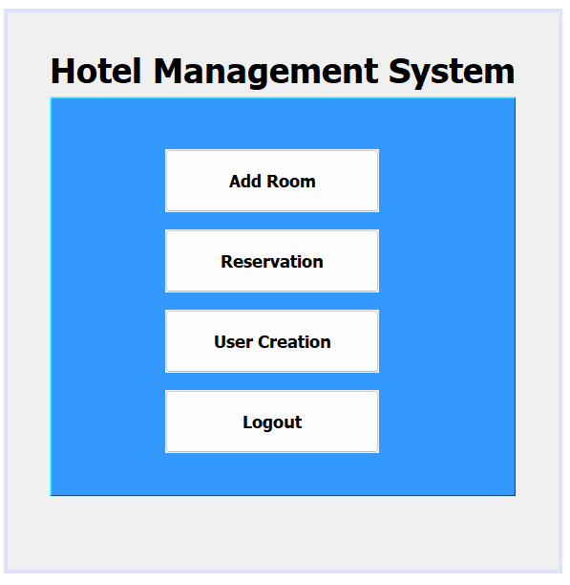
/*
* To change this license header, choose License Headers in Project Properties.
* To change this template file, choose Tools | Templates
* and open the template in the editor.
*/
package hotelmanagement;

/**
*
* @author Omar
*/
public class main extends javax.swing.JFrame {

/**
* Creates new form main
*/
public main() {
initComponents();
}

/**
* This method is called from within the constructor to initialize the form.
* WARNING: Do NOT modify this code. The content of this method is always
* regenerated by the Form Editor.
*/
@SuppressWarnings("unchecked")
// <editor-fold defaultstate="collapsed" desc="Generated Code">
private void initComponents() {

jLabel1 = new javax.swing.JLabel();
jPanel1 = new javax.swing.JPanel();
jButton1 = new javax.swing.JButton();
jButton2 = new javax.swing.JButton();
jButton3 = new javax.swing.JButton();
jButton4 = new javax.swing.JButton();

setDefaultCloseOperation(javax.swing.WindowConstants.EXIT_ON_CLOSE);
setBackground(new java.awt.Color(153, 153, 153));

jLabel1.setFont(new java.awt.Font("Tahoma", 1, 36)); // NOI18N
jLabel1.setText("Hotel Management System");

jPanel1.setBackground(new java.awt.Color(51, 153, 255));
jPanel1.setBorder(new javax.swing.border.SoftBevelBorder(javax.swing.border.BevelBorder.RAISED));

jButton1.setFont(new java.awt.Font("Tahoma", 1, 18)); // NOI18N
jButton1.setText("Add Room");
jButton1.addActionListener(new java.awt.event.ActionListener() {
public void actionPerformed(java.awt.event.ActionEvent evt) {
jButton1ActionPerformed(evt);
}
});

jButton2.setFont(new java.awt.Font("Tahoma", 1, 18)); // NOI18N
jButton2.setText("Reservation");
jButton2.addActionListener(new java.awt.event.ActionListener() {
public void actionPerformed(java.awt.event.ActionEvent evt) {
jButton2ActionPerformed(evt);
}
});

jButton3.setFont(new java.awt.Font("Tahoma", 1, 18)); // NOI18N
jButton3.setText("User Creation");
jButton3.addActionListener(new java.awt.event.ActionListener() {
public void actionPerformed(java.awt.event.ActionEvent evt) {
jButton3ActionPerformed(evt);
}
});

jButton4.setFont(new java.awt.Font("Tahoma", 1, 18)); // NOI18N
jButton4.setText("Logout");
jButton4.addActionListener(new java.awt.event.ActionListener() {
public void actionPerformed(java.awt.event.ActionEvent evt) {
jButton4ActionPerformed(evt);
}
});

javax.swing.GroupLayout jPanel1Layout = new javax.swing.GroupLayout(jPanel1);
jPanel1.setLayout(jPanel1Layout);
jPanel1Layout.setHorizontalGroup(
jPanel1Layout.createParallelGroup(javax.swing.GroupLayout.Alignment.LEADING)
.addGroup(jPanel1Layout.createSequentialGroup()
.addGap(118, 118, 118)
.addGroup(jPanel1Layout.createParallelGroup(javax.swing.GroupLayout.Alignment.LEADING)
.addComponent(jButton4, javax.swing.GroupLayout.PREFERRED_SIZE, 224, javax.swing.GroupLayout.PREFERRED_SIZE)
.addGroup(jPanel1Layout.createParallelGroup(javax.swing.GroupLayout.Alignment.TRAILING)
.addComponent(jButton2, javax.swing.GroupLayout.PREFERRED_SIZE, 224, javax.swing.GroupLayout.PREFERRED_SIZE)
.addGroup(jPanel1Layout.createParallelGroup(javax.swing.GroupLayout.Alignment.TRAILING, false)
.addComponent(jButton1, javax.swing.GroupLayout.Alignment.LEADING, javax.swing.GroupLayout.DEFAULT_SIZE, javax.swing.GroupLayout.DEFAULT_SIZE, Short.MAX_VALUE)
.addComponent(jButton3, javax.swing.GroupLayout.PREFERRED_SIZE, 224, javax.swing.GroupLayout.PREFERRED_SIZE))))
.addContainerGap(javax.swing.GroupLayout.DEFAULT_SIZE, Short.MAX_VALUE))
);
jPanel1Layout.setVerticalGroup(
jPanel1Layout.createParallelGroup(javax.swing.GroupLayout.Alignment.LEADING)
.addGroup(javax.swing.GroupLayout.Alignment.TRAILING, jPanel1Layout.createSequentialGroup()
.addContainerGap(52, Short.MAX_VALUE)
.addComponent(jButton1, javax.swing.GroupLayout.PREFERRED_SIZE, 66, javax.swing.GroupLayout.PREFERRED_SIZE)
.addGap(18, 18, 18)
.addComponent(jButton2, javax.swing.GroupLayout.PREFERRED_SIZE, 66, javax.swing.GroupLayout.PREFERRED_SIZE)
.addGap(18, 18, 18)
.addComponent(jButton3, javax.swing.GroupLayout.PREFERRED_SIZE, 66, javax.swing.GroupLayout.PREFERRED_SIZE)
.addGap(18, 18, 18)
.addComponent(jButton4, javax.swing.GroupLayout.PREFERRED_SIZE, 66, javax.swing.GroupLayout.PREFERRED_SIZE)
.addGap(42, 42, 42))
);

javax.swing.GroupLayout layout = new javax.swing.GroupLayout(getContentPane());
getContentPane().setLayout(layout);
layout.setHorizontalGroup(
layout.createParallelGroup(javax.swing.GroupLayout.Alignment.LEADING)
.addGroup(layout.createSequentialGroup()
.addGap(44, 44, 44)
.addGroup(layout.createParallelGroup(javax.swing.GroupLayout.Alignment.LEADING, false)
.addComponent(jLabel1, javax.swing.GroupLayout.DEFAULT_SIZE, javax.swing.GroupLayout.DEFAULT_SIZE, Short.MAX_VALUE)
.addComponent(jPanel1, javax.swing.GroupLayout.DEFAULT_SIZE, javax.swing.GroupLayout.DEFAULT_SIZE, Short.MAX_VALUE))
.addContainerGap(45, Short.MAX_VALUE))
);
layout.setVerticalGroup(
layout.createParallelGroup(javax.swing.GroupLayout.Alignment.LEADING)
.addGroup(layout.createSequentialGroup()
.addGap(38, 38, 38)
.addComponent(jLabel1)
.addPreferredGap(javax.swing.LayoutStyle.ComponentPlacement.RELATED)
.addComponent(jPanel1, javax.swing.GroupLayout.PREFERRED_SIZE, javax.swing.GroupLayout.DEFAULT_SIZE, javax.swing.GroupLayout.PREFERRED_SIZE)
.addContainerGap(77, Short.MAX_VALUE))
);

pack();
setLocationRelativeTo(null);
}// </editor-fold>

private void jButton1ActionPerformed(java.awt.event.ActionEvent evt) {
// TODO add your handling code here:
room r=new room();
r.setVisible(true);

}

private void jButton2ActionPerformed(java.awt.event.ActionEvent evt) {
// TODO add your handling code here:
reservation r=new reservation();
r.setVisible(true);
}

private void jButton3ActionPerformed(java.awt.event.ActionEvent evt) {
// TODO add your handling code here:
user r=new user();
r.setVisible(true);
}

private void jButton4ActionPerformed(java.awt.event.ActionEvent evt) {
// TODO add your handling code here:
login l=new login();
this.setVisible(false);
l.setVisible(true);
}

/**
* @param args the command line arguments
*/
public static void main(String args[]) {
/* Set the Nimbus look and feel */
//<editor-fold defaultstate="collapsed" desc=" Look and feel setting code (optional) ">
/* If Nimbus (introduced in Java SE 6) is not available, stay with the default look and feel.
* For details see http://download.oracle.com/javase/tutorial/uiswing/lookandfeel/plaf.html
*/
try {
for (javax.swing.UIManager.LookAndFeelInfo info : javax.swing.UIManager.getInstalledLookAndFeels()) {
if ("Nimbus".equals(info.getName())) {
javax.swing.UIManager.setLookAndFeel(info.getClassName());
break;
}
}
} catch (ClassNotFoundException ex) {
java.util.logging.Logger.getLogger(main.class.getName()).log(java.util.logging.Level.SEVERE, null, ex);
} catch (InstantiationException ex) {
java.util.logging.Logger.getLogger(main.class.getName()).log(java.util.logging.Level.SEVERE, null, ex);
} catch (IllegalAccessException ex) {
java.util.logging.Logger.getLogger(main.class.getName()).log(java.util.logging.Level.SEVERE, null, ex);
} catch (javax.swing.UnsupportedLookAndFeelException ex) {
java.util.logging.Logger.getLogger(main.class.getName()).log(java.util.logging.Level.SEVERE, null, ex);
}
//</editor-fold>

/* Create and display the form */
java.awt.EventQueue.invokeLater(new Runnable() {
public void run() {
new main().setVisible(true);
}
});
}

// Variables declaration - do not modify
private javax.swing.JButton jButton1;
private javax.swing.JButton jButton2;
private javax.swing.JButton jButton3;
private javax.swing.JButton jButton4;
private javax.swing.JLabel jLabel1;
private javax.swing.JPanel jPanel1;
// End of variables declaration
}

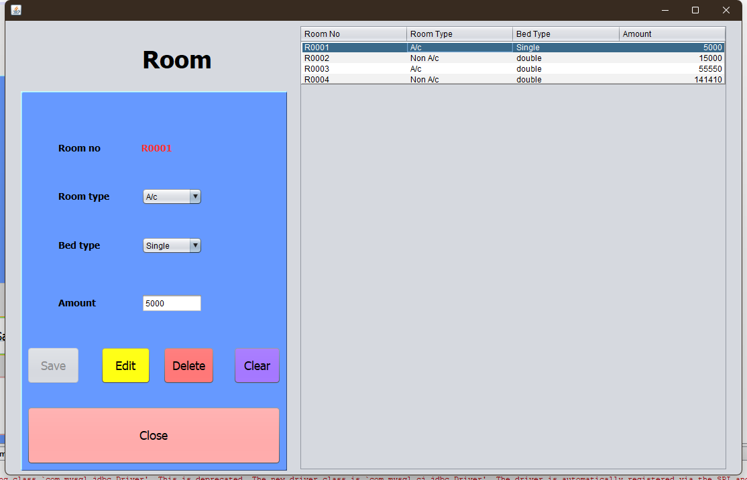
/*
* To change this license header, choose License Headers in Project Properties.
* To change this template file, choose Tools | Templates
* and open the template in the editor.
*/
package hotelmanagement;

import java.sql.Connection;
import java.sql.DriverManager;
import java.sql.PreparedStatement;
import java.sql.ResultSet;
import java.sql.ResultSetMetaData;
import java.sql.SQLException;
import java.sql.Statement;
import java.util.Vector;
import java.util.logging.Level;
import java.util.logging.Logger;
import javax.swing.JOptionPane;
import javax.swing.table.DefaultTableModel;

/**
*
* @author Omar
*/
public class room extends javax.swing.JFrame {

/**
* Creates new form room
*/
public room() {
initComponents();
connect();
autoID();
load_room();
}
Connection con;
PreparedStatement pst;
DefaultTableModel d;
public void connect(){
try {
Class.forName("com.mysql.jdbc.Driver");
con=DriverManager.getConnection("jdbc:mysql://localhost:3306/hotelmanagement", "root","");
} catch (ClassNotFoundException ex) {
Logger.getLogger(room.class.getName()).log(Level.SEVERE, null, ex);
} catch (SQLException ex) {
Logger.getLogger(room.class.getName()).log(Level.SEVERE, null, ex);
}
}
public void autoID(){
try {
Statement s=con.createStatement();
ResultSet rs=s.executeQuery("select MAX(rid) from room");
rs.next();
rs.getString("MAX(rid)");
if(rs.getString("MAX(rid)")==null){
jLabel6.setText("R0001");
}
else{
long id= Long.parseLong(rs.getString("MAX(rid)").substring(2,rs.getString("MAX(rid)").length()));
id++;
jLabel6.setText("R0"+ String.format("%03d", id));
}

} catch (SQLException ex) {
Logger.getLogger(room.class.getName()).log(Level.SEVERE, null, ex);
}
}
public void load_room(){
int c;
try {
pst=con.prepareStatement("select * from room");
ResultSet rs=pst.executeQuery();
ResultSetMetaData rsd=rs.getMetaData();
c=rsd.getColumnCount();
d=(DefaultTableModel)jTable1.getModel();
d.setRowCount(0);
while(rs.next()){
Vector v2=new Vector();
for(int i=1;i<=c;i++){
v2.add(rs.getString("rid"));
v2.add(rs.getString("rtype"));
v2.add(rs.getString("btype"));
v2.add(rs.getString("amount"));
}
d.addRow(v2);
}

} catch (SQLException ex) {
Logger.getLogger(room.class.getName()).log(Level.SEVERE, null, ex);
}

}

/**
* This method is called from within the constructor to initialize the form.
* WARNING: Do NOT modify this code. The content of this method is always
* regenerated by the Form Editor.
*/
@SuppressWarnings("unchecked")
// <editor-fold defaultstate="collapsed" desc="Generated Code">
private void initComponents() {

jPanel1 = new javax.swing.JPanel();
jLabel2 = new javax.swing.JLabel();
jLabel3 = new javax.swing.JLabel();
jLabel4 = new javax.swing.JLabel();
jLabel5 = new javax.swing.JLabel();
jLabel6 = new javax.swing.JLabel();
txtamount = new javax.swing.JTextField();
txttype = new javax.swing.JComboBox<>();
txtbtype = new javax.swing.JComboBox<>();
jButton1 = new javax.swing.JButton();
jButton2 = new javax.swing.JButton();
jButton3 = new javax.swing.JButton();
jButton4 = new javax.swing.JButton();
jButton5 = new javax.swing.JButton();
jLabel1 = new javax.swing.JLabel();
jScrollPane1 = new javax.swing.JScrollPane();
jTable1 = new javax.swing.JTable();

setDefaultCloseOperation(javax.swing.WindowConstants.EXIT_ON_CLOSE);
setBackground(new java.awt.Color(153, 153, 153));

jPanel1.setBackground(new java.awt.Color(102, 153, 255));
jPanel1.setBorder(new javax.swing.border.SoftBevelBorder(javax.swing.border.BevelBorder.RAISED));

jLabel2.setFont(new java.awt.Font("Tahoma", 1, 14)); // NOI18N
jLabel2.setText("Room no");

jLabel3.setFont(new java.awt.Font("Tahoma", 1, 14)); // NOI18N
jLabel3.setText("Room type");

jLabel4.setFont(new java.awt.Font("Tahoma", 1, 14)); // NOI18N
jLabel4.setText("Bed type");

jLabel5.setFont(new java.awt.Font("Tahoma", 1, 14)); // NOI18N
jLabel5.setText("Amount");

jLabel6.setFont(new java.awt.Font("Tahoma", 1, 14)); // NOI18N
jLabel6.setForeground(new java.awt.Color(255, 51, 51));
jLabel6.setText("jLabel6");

txttype.setModel(new javax.swing.DefaultComboBoxModel<>(new String[] { "A/c", "Non A/c", " " }));

txtbtype.setModel(new javax.swing.DefaultComboBoxModel<>(new String[] { "Single", "double" }));

jButton1.setBackground(new java.awt.Color(102, 255, 102));
jButton1.setFont(new java.awt.Font("Tahoma", 0, 18)); // NOI18N
jButton1.setText("Save");
jButton1.addActionListener(new java.awt.event.ActionListener() {
public void actionPerformed(java.awt.event.ActionEvent evt) {
jButton1ActionPerformed(evt);
}
});

jButton2.setBackground(new java.awt.Color(255, 255, 0));
jButton2.setFont(new java.awt.Font("Tahoma", 0, 18)); // NOI18N
jButton2.setText("Edit");
jButton2.addActionListener(new java.awt.event.ActionListener() {
public void actionPerformed(java.awt.event.ActionEvent evt) {
jButton2ActionPerformed(evt);
}
});

jButton3.setBackground(new java.awt.Color(255, 102, 102));
jButton3.setFont(new java.awt.Font("Tahoma", 0, 18)); // NOI18N
jButton3.setText("Delete");
jButton3.addActionListener(new java.awt.event.ActionListener() {
public void actionPerformed(java.awt.event.ActionEvent evt) {
jButton3ActionPerformed(evt);
}
});

jButton4.setBackground(new java.awt.Color(153, 102, 255));
jButton4.setFont(new java.awt.Font("Tahoma", 0, 18)); // NOI18N
jButton4.setText("Clear");
jButton4.addActionListener(new java.awt.event.ActionListener() {
public void actionPerformed(java.awt.event.ActionEvent evt) {
jButton4ActionPerformed(evt);
}
});

jButton5.setBackground(new java.awt.Color(255, 153, 153));
jButton5.setFont(new java.awt.Font("Tahoma", 0, 18)); // NOI18N
jButton5.setText("Close");
jButton5.addActionListener(new java.awt.event.ActionListener() {
public void actionPerformed(java.awt.event.ActionEvent evt) {
jButton5ActionPerformed(evt);
}
});

javax.swing.GroupLayout jPanel1Layout = new javax.swing.GroupLayout(jPanel1);
jPanel1.setLayout(jPanel1Layout);
jPanel1Layout.setHorizontalGroup(
jPanel1Layout.createParallelGroup(javax.swing.GroupLayout.Alignment.LEADING)
.addGroup(jPanel1Layout.createSequentialGroup()
.addGap(53, 53, 53)
.addGroup(jPanel1Layout.createParallelGroup(javax.swing.GroupLayout.Alignment.LEADING, false)
.addComponent(jLabel3, javax.swing.GroupLayout.DEFAULT_SIZE, javax.swing.GroupLayout.DEFAULT_SIZE, Short.MAX_VALUE)
.addComponent(jLabel5, javax.swing.GroupLayout.DEFAULT_SIZE, javax.swing.GroupLayout.DEFAULT_SIZE, Short.MAX_VALUE)
.addComponent(jLabel4, javax.swing.GroupLayout.DEFAULT_SIZE, javax.swing.GroupLayout.DEFAULT_SIZE, Short.MAX_VALUE)
.addComponent(jLabel2, javax.swing.GroupLayout.DEFAULT_SIZE, javax.swing.GroupLayout.DEFAULT_SIZE, Short.MAX_VALUE))
.addGap(48, 48, 48)
.addGroup(jPanel1Layout.createParallelGroup(javax.swing.GroupLayout.Alignment.LEADING, false)
.addComponent(jLabel6, javax.swing.GroupLayout.DEFAULT_SIZE, javax.swing.GroupLayout.DEFAULT_SIZE, Short.MAX_VALUE)
.addComponent(txtamount)
.addComponent(txttype, 0, 91, Short.MAX_VALUE)
.addComponent(txtbtype, 0, javax.swing.GroupLayout.DEFAULT_SIZE, Short.MAX_VALUE))
.addContainerGap(javax.swing.GroupLayout.DEFAULT_SIZE, Short.MAX_VALUE))
.addGroup(javax.swing.GroupLayout.Alignment.TRAILING, jPanel1Layout.createSequentialGroup()
.addContainerGap()
.addGroup(jPanel1Layout.createParallelGroup(javax.swing.GroupLayout.Alignment.TRAILING)
.addGroup(javax.swing.GroupLayout.Alignment.LEADING, jPanel1Layout.createSequentialGroup()
.addComponent(jButton1, javax.swing.GroupLayout.PREFERRED_SIZE, 79, javax.swing.GroupLayout.PREFERRED_SIZE)
.addPreferredGap(javax.swing.LayoutStyle.ComponentPlacement.RELATED, 31, Short.MAX_VALUE)
.addComponent(jButton2, javax.swing.GroupLayout.PREFERRED_SIZE, 75, javax.swing.GroupLayout.PREFERRED_SIZE)
.addGap(18, 18, 18)
.addComponent(jButton3)
.addGap(28, 28, 28)
.addComponent(jButton4, javax.swing.GroupLayout.PREFERRED_SIZE, 71, javax.swing.GroupLayout.PREFERRED_SIZE))
.addComponent(jButton5, javax.swing.GroupLayout.Alignment.LEADING, javax.swing.GroupLayout.DEFAULT_SIZE, javax.swing.GroupLayout.DEFAULT_SIZE, Short.MAX_VALUE))
.addContainerGap())
);
jPanel1Layout.setVerticalGroup(
jPanel1Layout.createParallelGroup(javax.swing.GroupLayout.Alignment.LEADING)
.addGroup(jPanel1Layout.createSequentialGroup()
.addGap(73, 73, 73)
.addGroup(jPanel1Layout.createParallelGroup(javax.swing.GroupLayout.Alignment.BASELINE)
.addComponent(jLabel2)
.addComponent(jLabel6))
.addGap(51, 51, 51)
.addGroup(jPanel1Layout.createParallelGroup(javax.swing.GroupLayout.Alignment.BASELINE)
.addComponent(jLabel3)
.addComponent(txttype, javax.swing.GroupLayout.PREFERRED_SIZE, javax.swing.GroupLayout.DEFAULT_SIZE, javax.swing.GroupLayout.PREFERRED_SIZE))
.addGap(47, 47, 47)
.addGroup(jPanel1Layout.createParallelGroup(javax.swing.GroupLayout.Alignment.BASELINE)
.addComponent(jLabel4)
.addComponent(txtbtype, javax.swing.GroupLayout.PREFERRED_SIZE, javax.swing.GroupLayout.DEFAULT_SIZE, javax.swing.GroupLayout.PREFERRED_SIZE))
.addGap(59, 59, 59)
.addGroup(jPanel1Layout.createParallelGroup(javax.swing.GroupLayout.Alignment.BASELINE)
.addComponent(jLabel5)
.addComponent(txtamount, javax.swing.GroupLayout.PREFERRED_SIZE, javax.swing.GroupLayout.DEFAULT_SIZE, javax.swing.GroupLayout.PREFERRED_SIZE))
.addPreferredGap(javax.swing.LayoutStyle.ComponentPlacement.RELATED, 51, Short.MAX_VALUE)
.addGroup(jPanel1Layout.createParallelGroup(javax.swing.GroupLayout.Alignment.BASELINE)
.addComponent(jButton1, javax.swing.GroupLayout.PREFERRED_SIZE, 56, javax.swing.GroupLayout.PREFERRED_SIZE)
.addComponent(jButton2, javax.swing.GroupLayout.PREFERRED_SIZE, 56, javax.swing.GroupLayout.PREFERRED_SIZE)
.addComponent(jButton3, javax.swing.GroupLayout.PREFERRED_SIZE, 56, javax.swing.GroupLayout.PREFERRED_SIZE)
.addComponent(jButton4, javax.swing.GroupLayout.PREFERRED_SIZE, 56, javax.swing.GroupLayout.PREFERRED_SIZE))
.addGap(33, 33, 33)
.addComponent(jButton5, javax.swing.GroupLayout.PREFERRED_SIZE, 87, javax.swing.GroupLayout.PREFERRED_SIZE)
.addContainerGap())
);

jLabel1.setFont(new java.awt.Font("Tahoma", 1, 36)); // NOI18N
jLabel1.setText("Room");

jTable1.setBorder(javax.swing.BorderFactory.createBevelBorder(javax.swing.border.BevelBorder.RAISED));
jTable1.setModel(new javax.swing.table.DefaultTableModel(
new Object [][] {

},
new String [] {
"Room No", "Room Type", "Bed Type", "Amount"
}
) {
Class[] types = new Class [] {
java.lang.String.class, java.lang.String.class, java.lang.String.class, java.lang.Integer.class
};

public Class getColumnClass(int columnIndex) {
return types [columnIndex];
}
});
jTable1.addMouseListener(new java.awt.event.MouseAdapter() {
public void mouseClicked(java.awt.event.MouseEvent evt) {
jTable1MouseClicked(evt);
}
});
jScrollPane1.setViewportView(jTable1);

javax.swing.GroupLayout layout = new javax.swing.GroupLayout(getContentPane());
getContentPane().setLayout(layout);
layout.setHorizontalGroup(
layout.createParallelGroup(javax.swing.GroupLayout.Alignment.LEADING)
.addGroup(layout.createSequentialGroup()
.addGroup(layout.createParallelGroup(javax.swing.GroupLayout.Alignment.LEADING)
.addGroup(layout.createSequentialGroup()
.addGap(204, 204, 204)
.addComponent(jLabel1)
.addPreferredGap(javax.swing.LayoutStyle.ComponentPlacement.RELATED, javax.swing.GroupLayout.DEFAULT_SIZE, Short.MAX_VALUE))
.addGroup(layout.createSequentialGroup()
.addGap(0, 23, Short.MAX_VALUE)
.addComponent(jPanel1, javax.swing.GroupLayout.PREFERRED_SIZE, javax.swing.GroupLayout.DEFAULT_SIZE, javax.swing.GroupLayout.PREFERRED_SIZE)
.addGap(18, 18, 18)))
.addComponent(jScrollPane1, javax.swing.GroupLayout.PREFERRED_SIZE, 639, javax.swing.GroupLayout.PREFERRED_SIZE)
.addGap(21, 21, 21))
);
layout.setVerticalGroup(
layout.createParallelGroup(javax.swing.GroupLayout.Alignment.LEADING)
.addGroup(layout.createSequentialGroup()
.addGroup(layout.createParallelGroup(javax.swing.GroupLayout.Alignment.LEADING)
.addGroup(layout.createSequentialGroup()
.addGap(35, 35, 35)
.addComponent(jLabel1)
.addGap(26, 26, 26)
.addComponent(jPanel1, javax.swing.GroupLayout.DEFAULT_SIZE, javax.swing.GroupLayout.DEFAULT_SIZE, Short.MAX_VALUE))
.addGroup(layout.createSequentialGroup()
.addContainerGap()
.addComponent(jScrollPane1)))
.addContainerGap())
);

pack();
setLocationRelativeTo(null);
}// </editor-fold>

private void jButton1ActionPerformed(java.awt.event.ActionEvent evt) {
// TODO add your handling code here:
String roomno=jLabel6.getText();
String roomtype=txttype.getSelectedItem().toString();
String bedtype=txtbtype.getSelectedItem().toString();
String amount=txtamount.getText();

try {
pst=con.prepareStatement("insert into room(rid,rtype,btype,amount) values (?,?,?,?)");
pst.setString(1, roomno);
pst.setString(2, roomtype);
pst.setString(3, bedtype);
pst.setString(4, amount);
pst.executeUpdate();
JOptionPane.showMessageDialog(null,"Room Added");
txttype.setSelectedIndex(-1);
txtbtype.setSelectedIndex(-1);
txtamount.setText("");
autoID();
load_room();
} catch (SQLException ex) {
Logger.getLogger(room.class.getName()).log(Level.SEVERE, null, ex);
}
}

private void jTable1MouseClicked(java.awt.event.MouseEvent evt) {
// TODO add your handling code here:
d=(DefaultTableModel)jTable1.getModel();
int selectIndex=jTable1.getSelectedRow();
jLabel6.setText(d.getValueAt(selectIndex, 0).toString());
txttype.setSelectedItem(d.getValueAt(selectIndex, 1).toString());
txtbtype.setSelectedItem(d.getValueAt(selectIndex, 2).toString());
txtamount.setText(d.getValueAt(selectIndex, 3).toString());
jButton1.setEnabled(false);
}

private void jButton2ActionPerformed(java.awt.event.ActionEvent evt) {
// TODO add your handling code here:
String roomno=jLabel6.getText();
String roomtype=txttype.getSelectedItem().toString();
String bedtype=txtbtype.getSelectedItem().toString();
String amount=txtamount.getText();

try {
pst=con.prepareStatement("update room set rtype=?,btype=?,amount=? where rid= ?");
pst.setString(1, roomtype);
pst.setString(2, bedtype);
pst.setString(3, amount);
pst.setString(4, roomno);
pst.executeUpdate();
JOptionPane.showMessageDialog(null,"Room Edited");
txttype.setSelectedIndex(-1);
txtbtype.setSelectedIndex(-1);
txtamount.setText("");
autoID();
load_room();
jButton1.setEnabled(false);
} catch (SQLException ex) {
Logger.getLogger(room.class.getName()).log(Level.SEVERE, null, ex);
}

}

private void jButton4ActionPerformed(java.awt.event.ActionEvent evt) {
// TODO add your handling code here:
txttype.setSelectedIndex(-1);
txtbtype.setSelectedIndex(-1);
txtamount.setText("");
autoID();
load_room();
jButton1.setEnabled(true);
}

private void jButton3ActionPerformed(java.awt.event.ActionEvent evt) {
// TODO add your handling code here:
String roomno=jLabel6.getText();

try {
pst=con.prepareStatement("delete from room where rid=?");
pst.setString(1, roomno);
pst.executeUpdate();
JOptionPane.showMessageDialog(null,"Room Deleted");
txttype.setSelectedIndex(-1);
txtbtype.setSelectedIndex(-1);
txtamount.setText("");
autoID();
load_room();
jButton1.setEnabled(false);
} catch (SQLException ex) {
Logger.getLogger(room.class.getName()).log(Level.SEVERE, null, ex);
}
}

private void jButton5ActionPerformed(java.awt.event.ActionEvent evt) {
// TODO add your handling code here:
this.setVisible(false);

}

/**
* @param args the command line arguments
*/
public static void main(String args[]) {
/* Set the Nimbus look and feel */
//<editor-fold defaultstate="collapsed" desc=" Look and feel setting code (optional) ">
/* If Nimbus (introduced in Java SE 6) is not available, stay with the default look and feel.
* For details see http://download.oracle.com/javase/tutorial/uiswing/lookandfeel/plaf.html
*/
try {
for (javax.swing.UIManager.LookAndFeelInfo info : javax.swing.UIManager.getInstalledLookAndFeels()) {
if ("Nimbus".equals(info.getName())) {
javax.swing.UIManager.setLookAndFeel(info.getClassName());
break;
}
}
} catch (ClassNotFoundException ex) {
java.util.logging.Logger.getLogger(room.class.getName()).log(java.util.logging.Level.SEVERE, null, ex);
} catch (InstantiationException ex) {
java.util.logging.Logger.getLogger(room.class.getName()).log(java.util.logging.Level.SEVERE, null, ex);
} catch (IllegalAccessException ex) {
java.util.logging.Logger.getLogger(room.class.getName()).log(java.util.logging.Level.SEVERE, null, ex);
} catch (javax.swing.UnsupportedLookAndFeelException ex) {
java.util.logging.Logger.getLogger(room.class.getName()).log(java.util.logging.Level.SEVERE, null, ex);
}
//</editor-fold>

/* Create and display the form */
java.awt.EventQueue.invokeLater(new Runnable() {
public void run() {
new room().setVisible(true);
}
});
}

// Variables declaration - do not modify
private javax.swing.JButton jButton1;
private javax.swing.JButton jButton2;
private javax.swing.JButton jButton3;
private javax.swing.JButton jButton4;
private javax.swing.JButton jButton5;
private javax.swing.JLabel jLabel1;
private javax.swing.JLabel jLabel2;
private javax.swing.JLabel jLabel3;
private javax.swing.JLabel jLabel4;
private javax.swing.JLabel jLabel5;
private javax.swing.JLabel jLabel6;
private javax.swing.JPanel jPanel1;
private javax.swing.JScrollPane jScrollPane1;
private javax.swing.JTable jTable1;
private javax.swing.JTextField txtamount;
private javax.swing.JComboBox<String> txtbtype;
private javax.swing.JComboBox<String> txttype;
// End of variables declaration
}

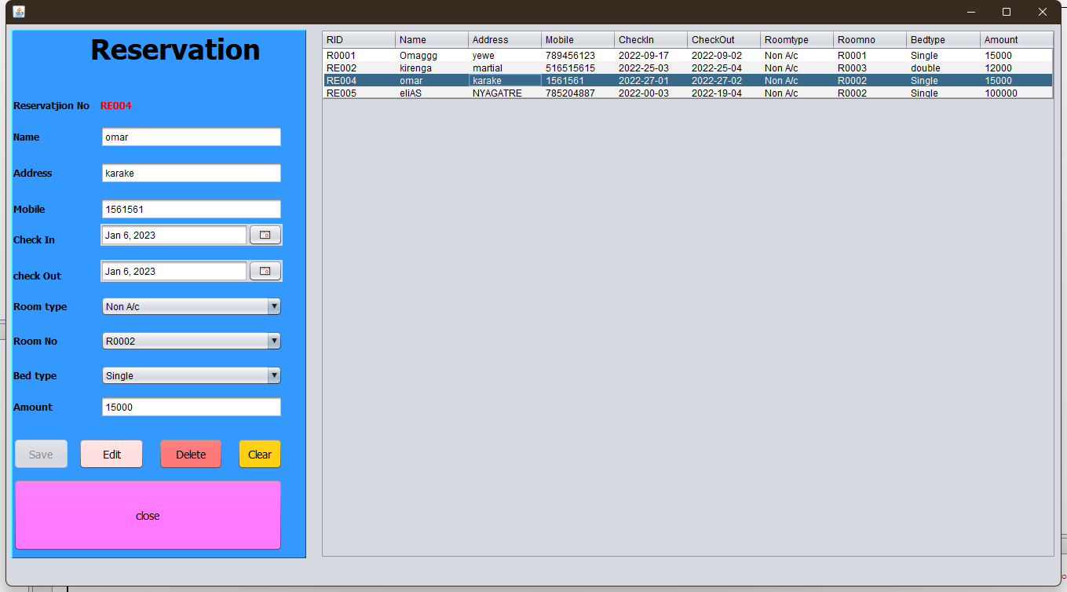
/*
* To change this license header, choose License Headers in Project Properties.
* To change this template file, choose Tools | Templates
* and open the template in the editor.
*/
package hotelmanagement;

import java.sql.Connection;
import java.sql.DriverManager;
import java.sql.PreparedStatement;
import java.sql.ResultSet;
import java.sql.ResultSetMetaData;
import java.sql.SQLException;
import java.sql.Statement;
import java.text.ParseException;
import java.text.SimpleDateFormat;
import java.util.Date;
import java.util.Vector;
import java.util.logging.Level;
import java.util.logging.Logger;
import javax.swing.JOptionPane;
import javax.swing.table.DefaultTableModel;

/**
*
* @author Omar
*/
public class reservation extends javax.swing.JFrame {

/**
* Creates new form reservation
*/
public reservation() {
initComponents();
connect();
autoID();
roomtypeL();
roomNoL();
bedTypeL();
load_reservation();

}
Connection con;
PreparedStatement pst;
DefaultTableModel d;
public void connect(){
try {
Class.forName("com.mysql.jdbc.Driver");
con=DriverManager.getConnection("jdbc:mysql://localhost:3306/hotelmanagement", "root","");
} catch (ClassNotFoundException ex) {
Logger.getLogger(room.class.getName()).log(Level.SEVERE, null, ex);
} catch (SQLException ex) {
Logger.getLogger(room.class.getName()).log(Level.SEVERE, null, ex);
}
}
public void autoID(){
try {
Statement s=con.createStatement();
ResultSet rs=s.executeQuery("select MAX(reid) from reservation");
rs.next();
rs.getString("MAX(reid)");
if(rs.getString("MAX(reid)")==null){
jLabel12.setText("R0001");
}
else{
long id= Long.parseLong(rs.getString("MAX(reid)").substring(2,rs.getString("MAX(reid)").length()));
id++;
jLabel12.setText("RE"+ String.format("%03d", id));
}

} catch (SQLException ex) {
Logger.getLogger(room.class.getName()).log(Level.SEVERE, null, ex);
}
}
public void roomtypeL(){
try {
pst=con.prepareStatement("select distinct rtype from room");
ResultSet rs=pst.executeQuery();
txtrtype.removeAllItems();
while(rs.next()){
txtrtype.addItem(rs.getString("rtype"));
}
} catch (SQLException ex) {
Logger.getLogger(reservation.class.getName()).log(Level.SEVERE, null, ex);
}
}
public void load_reservation(){
int c;
try {
pst=con.prepareStatement("select * from reservation");
ResultSet rs=pst.executeQuery();
ResultSetMetaData rsd=rs.getMetaData();
c=rsd.getColumnCount();
d=(DefaultTableModel)jTable2.getModel();
d.setRowCount(0);
while(rs.next()){
Vector v2=new Vector();
for(int i=1;i<=c;i++){
v2.add(rs.getString("reid"));
v2.add(rs.getString("name"));
v2.add(rs.getString("address"));
v2.add(rs.getString("mobile"));
v2.add(rs.getString("checkin"));
v2.add(rs.getString("checkout"));
v2.add(rs.getString("bedtype"));
v2.add(rs.getString("roomno"));
v2.add(rs.getString("rtype"));
v2.add(rs.getString("amount"));
}
d.addRow(v2);
}

} catch (SQLException ex) {
Logger.getLogger(room.class.getName()).log(Level.SEVERE, null, ex);
}

}
public void roomNoL(){
try {
pst=con.prepareStatement("select distinct rid from room");
ResultSet rs=pst.executeQuery();
txtrno.removeAllItems();
while(rs.next()){
txtrno.addItem(rs.getString("rid"));
}
} catch (SQLException ex) {
Logger.getLogger(reservation.class.getName()).log(Level.SEVERE, null, ex);
}
}
public void bedTypeL(){
try {
pst=con.prepareStatement("select distinct btype from room");
ResultSet rs=pst.executeQuery();
txtbtype.removeAllItems();
while(rs.next()){
txtbtype.addItem(rs.getString("btype"));
}
} catch (SQLException ex) {
Logger.getLogger(reservation.class.getName()).log(Level.SEVERE, null, ex);
}
}

/**
* This method is called from within the constructor to initialize the form.
* WARNING: Do NOT modify this code. The content of this method is always
* regenerated by the Form Editor.
*/
@SuppressWarnings("unchecked")
// <editor-fold defaultstate="collapsed" desc="Generated Code">
private void initComponents() {

jPanel1 = new javax.swing.JPanel();
jLabel1 = new javax.swing.JLabel();
jLabel2 = new javax.swing.JLabel();
jLabel3 = new javax.swing.JLabel();
jLabel4 = new javax.swing.JLabel();
jLabel5 = new javax.swing.JLabel();
jLabel6 = new javax.swing.JLabel();
jLabel7 = new javax.swing.JLabel();
jLabel8 = new javax.swing.JLabel();
jLabel9 = new javax.swing.JLabel();
jLabel10 = new javax.swing.JLabel();
jLabel11 = new javax.swing.JLabel();
txtname = new javax.swing.JTextField();
txtaddress = new javax.swing.JTextField();
txtmobile = new javax.swing.JTextField();
txtamount = new javax.swing.JTextField();
txtrtype = new javax.swing.JComboBox<>();
txtrno = new javax.swing.JComboBox<>();
txtbtype = new javax.swing.JComboBox<>();
txtcheckin = new com.toedter.calendar.JDateChooser();
txtcheckout = new com.toedter.calendar.JDateChooser();
jButton1 = new javax.swing.JButton();
jButton2 = new javax.swing.JButton();
jButton3 = new javax.swing.JButton();
jButton4 = new javax.swing.JButton();
jLabel12 = new javax.swing.JLabel();
jButton5 = new javax.swing.JButton();
jScrollPane1 = new javax.swing.JScrollPane();
jTable2 = new javax.swing.JTable();

setDefaultCloseOperation(javax.swing.WindowConstants.EXIT_ON_CLOSE);
setBackground(new java.awt.Color(153, 153, 153));

jPanel1.setBackground(new java.awt.Color(51, 153, 255));
jPanel1.setBorder(new javax.swing.border.SoftBevelBorder(javax.swing.border.BevelBorder.RAISED));

jLabel1.setFont(new java.awt.Font("Tahoma", 1, 36)); // NOI18N
jLabel1.setText("Reservation");

jLabel2.setFont(new java.awt.Font("Tahoma", 1, 12)); // NOI18N
jLabel2.setText("Reservatjion No");

jLabel3.setFont(new java.awt.Font("Tahoma", 1, 12)); // NOI18N
jLabel3.setText("Name");

jLabel4.setFont(new java.awt.Font("Tahoma", 1, 12)); // NOI18N
jLabel4.setText("Address");

jLabel5.setFont(new java.awt.Font("Tahoma", 1, 12)); // NOI18N
jLabel5.setText("Mobile");

jLabel6.setFont(new java.awt.Font("Tahoma", 1, 12)); // NOI18N
jLabel6.setText("Check In");

jLabel7.setFont(new java.awt.Font("Tahoma", 1, 12)); // NOI18N
jLabel7.setText("check Out");

jLabel8.setFont(new java.awt.Font("Tahoma", 1, 12)); // NOI18N
jLabel8.setText("Room type");

jLabel9.setFont(new java.awt.Font("Tahoma", 1, 12)); // NOI18N
jLabel9.setText("Bed type");

jLabel10.setFont(new java.awt.Font("Tahoma", 1, 12)); // NOI18N
jLabel10.setText("Room No");

jLabel11.setFont(new java.awt.Font("Tahoma", 1, 12)); // NOI18N
jLabel11.setText("Amount");

jButton1.setBackground(new java.awt.Color(153, 255, 153));
jButton1.setFont(new java.awt.Font("Tahoma", 0, 14)); // NOI18N
jButton1.setText("Save");
jButton1.addActionListener(new java.awt.event.ActionListener() {
public void actionPerformed(java.awt.event.ActionEvent evt) {
jButton1ActionPerformed(evt);
}
});

jButton2.setBackground(new java.awt.Color(255, 204, 204));
jButton2.setFont(new java.awt.Font("Tahoma", 0, 14)); // NOI18N
jButton2.setText("Edit");
jButton2.addActionListener(new java.awt.event.ActionListener() {
public void actionPerformed(java.awt.event.ActionEvent evt) {
jButton2ActionPerformed(evt);
}
});

jButton3.setBackground(new java.awt.Color(255, 102, 102));
jButton3.setFont(new java.awt.Font("Tahoma", 0, 14)); // NOI18N
jButton3.setText("Delete");
jButton3.addActionListener(new java.awt.event.ActionListener() {
public void actionPerformed(java.awt.event.ActionEvent evt) {
jButton3ActionPerformed(evt);
}
});

jButton4.setBackground(new java.awt.Color(255, 204, 0));
jButton4.setFont(new java.awt.Font("Tahoma", 0, 14)); // NOI18N
jButton4.setText("Clear");
jButton4.addActionListener(new java.awt.event.ActionListener() {
public void actionPerformed(java.awt.event.ActionEvent evt) {
jButton4ActionPerformed(evt);
}
});

jLabel12.setFont(new java.awt.Font("Tahoma", 1, 13)); // NOI18N
jLabel12.setForeground(new java.awt.Color(255, 0, 0));
jLabel12.setText("jLabel12");

jButton5.setBackground(new java.awt.Color(255, 102, 255));
jButton5.setFont(new java.awt.Font("Tahoma", 0, 14)); // NOI18N
jButton5.setText("close");
jButton5.addActionListener(new java.awt.event.ActionListener() {
public void actionPerformed(java.awt.event.ActionEvent evt) {
jButton5ActionPerformed(evt);
}
});

javax.swing.GroupLayout jPanel1Layout = new javax.swing.GroupLayout(jPanel1);
jPanel1.setLayout(jPanel1Layout);
jPanel1Layout.setHorizontalGroup(
jPanel1Layout.createParallelGroup(javax.swing.GroupLayout.Alignment.LEADING)
.addGroup(jPanel1Layout.createSequentialGroup()
.addGroup(jPanel1Layout.createParallelGroup(javax.swing.GroupLayout.Alignment.LEADING)
.addGroup(jPanel1Layout.createSequentialGroup()
.addComponent(jButton1, javax.swing.GroupLayout.PREFERRED_SIZE, 71, javax.swing.GroupLayout.PREFERRED_SIZE)
.addPreferredGap(javax.swing.LayoutStyle.ComponentPlacement.UNRELATED)
.addComponent(jButton2, javax.swing.GroupLayout.PREFERRED_SIZE, 84, javax.swing.GroupLayout.PREFERRED_SIZE)
.addGap(18, 18, 18)
.addComponent(jButton3, javax.swing.GroupLayout.PREFERRED_SIZE, 82, javax.swing.GroupLayout.PREFERRED_SIZE)
.addGap(18, 18, 18)
.addComponent(jButton4, javax.swing.GroupLayout.DEFAULT_SIZE, javax.swing.GroupLayout.DEFAULT_SIZE, Short.MAX_VALUE))
.addGroup(jPanel1Layout.createSequentialGroup()
.addGroup(jPanel1Layout.createParallelGroup(javax.swing.GroupLayout.Alignment.LEADING, false)
.addComponent(jLabel2, javax.swing.GroupLayout.DEFAULT_SIZE, javax.swing.GroupLayout.DEFAULT_SIZE, Short.MAX_VALUE)
.addComponent(jLabel3, javax.swing.GroupLayout.DEFAULT_SIZE, javax.swing.GroupLayout.DEFAULT_SIZE, Short.MAX_VALUE)
.addComponent(jLabel4, javax.swing.GroupLayout.DEFAULT_SIZE, javax.swing.GroupLayout.DEFAULT_SIZE, Short.MAX_VALUE)
.addComponent(jLabel5, javax.swing.GroupLayout.DEFAULT_SIZE, javax.swing.GroupLayout.DEFAULT_SIZE, Short.MAX_VALUE)
.addComponent(jLabel6, javax.swing.GroupLayout.DEFAULT_SIZE, javax.swing.GroupLayout.DEFAULT_SIZE, Short.MAX_VALUE)
.addComponent(jLabel7, javax.swing.GroupLayout.DEFAULT_SIZE, javax.swing.GroupLayout.DEFAULT_SIZE, Short.MAX_VALUE)
.addComponent(jLabel8, javax.swing.GroupLayout.DEFAULT_SIZE, javax.swing.GroupLayout.DEFAULT_SIZE, Short.MAX_VALUE)
.addComponent(jLabel9, javax.swing.GroupLayout.DEFAULT_SIZE, javax.swing.GroupLayout.DEFAULT_SIZE, Short.MAX_VALUE)
.addComponent(jLabel10, javax.swing.GroupLayout.DEFAULT_SIZE, javax.swing.GroupLayout.DEFAULT_SIZE, Short.MAX_VALUE)
.addComponent(jLabel11, javax.swing.GroupLayout.PREFERRED_SIZE, 97, javax.swing.GroupLayout.PREFERRED_SIZE))
.addGap(14, 14, 14)
.addGroup(jPanel1Layout.createParallelGroup(javax.swing.GroupLayout.Alignment.LEADING)
.addComponent(jLabel12, javax.swing.GroupLayout.Alignment.TRAILING, javax.swing.GroupLayout.DEFAULT_SIZE, javax.swing.GroupLayout.DEFAULT_SIZE, Short.MAX_VALUE)
.addComponent(txtaddress)
.addComponent(txtmobile)
.addComponent(txtamount)
.addComponent(txtrtype, 0, javax.swing.GroupLayout.DEFAULT_SIZE, Short.MAX_VALUE)
.addComponent(txtrno, 0, javax.swing.GroupLayout.DEFAULT_SIZE, Short.MAX_VALUE)
.addComponent(txtbtype, 0, javax.swing.GroupLayout.DEFAULT_SIZE, Short.MAX_VALUE)
.addComponent(txtcheckin, javax.swing.GroupLayout.DEFAULT_SIZE, javax.swing.GroupLayout.DEFAULT_SIZE, Short.MAX_VALUE)
.addComponent(txtcheckout, javax.swing.GroupLayout.DEFAULT_SIZE, javax.swing.GroupLayout.DEFAULT_SIZE, Short.MAX_VALUE)
.addComponent(txtname)))
.addComponent(jButton5, javax.swing.GroupLayout.DEFAULT_SIZE, javax.swing.GroupLayout.DEFAULT_SIZE, Short.MAX_VALUE)
.addGroup(jPanel1Layout.createSequentialGroup()
.addGap(98, 98, 98)
.addComponent(jLabel1, javax.swing.GroupLayout.DEFAULT_SIZE, javax.swing.GroupLayout.DEFAULT_SIZE, Short.MAX_VALUE)))
.addGap(27, 27, 27))
);
jPanel1Layout.setVerticalGroup(
jPanel1Layout.createParallelGroup(javax.swing.GroupLayout.Alignment.LEADING)
.addGroup(jPanel1Layout.createSequentialGroup()
.addComponent(jLabel1)
.addGap(42, 42, 42)
.addGroup(jPanel1Layout.createParallelGroup(javax.swing.GroupLayout.Alignment.TRAILING)
.addComponent(jLabel2)
.addComponent(jLabel12))
.addGap(18, 18, 18)
.addGroup(jPanel1Layout.createParallelGroup(javax.swing.GroupLayout.Alignment.TRAILING)
.addGroup(jPanel1Layout.createSequentialGroup()
.addGroup(jPanel1Layout.createParallelGroup(javax.swing.GroupLayout.Alignment.BASELINE)
.addComponent(jLabel3)
.addComponent(txtname, javax.swing.GroupLayout.PREFERRED_SIZE, javax.swing.GroupLayout.DEFAULT_SIZE, javax.swing.GroupLayout.PREFERRED_SIZE))
.addGap(18, 18, 18)
.addGroup(jPanel1Layout.createParallelGroup(javax.swing.GroupLayout.Alignment.BASELINE)
.addComponent(jLabel4)
.addComponent(txtaddress, javax.swing.GroupLayout.PREFERRED_SIZE, javax.swing.GroupLayout.DEFAULT_SIZE, javax.swing.GroupLayout.PREFERRED_SIZE))
.addGap(18, 18, 18)
.addGroup(jPanel1Layout.createParallelGroup(javax.swing.GroupLayout.Alignment.BASELINE)
.addComponent(jLabel5)
.addComponent(txtmobile, javax.swing.GroupLayout.PREFERRED_SIZE, javax.swing.GroupLayout.DEFAULT_SIZE, javax.swing.GroupLayout.PREFERRED_SIZE))
.addGap(18, 18, 18)
.addComponent(jLabel6))
.addComponent(txtcheckin, javax.swing.GroupLayout.PREFERRED_SIZE, javax.swing.GroupLayout.DEFAULT_SIZE, javax.swing.GroupLayout.PREFERRED_SIZE))
.addGap(18, 18, 18)
.addGroup(jPanel1Layout.createParallelGroup(javax.swing.GroupLayout.Alignment.TRAILING)
.addComponent(jLabel7)
.addComponent(txtcheckout, javax.swing.GroupLayout.PREFERRED_SIZE, javax.swing.GroupLayout.DEFAULT_SIZE, javax.swing.GroupLayout.PREFERRED_SIZE))
.addGap(18, 18, 18)
.addGroup(jPanel1Layout.createParallelGroup(javax.swing.GroupLayout.Alignment.BASELINE)
.addComponent(jLabel8)
.addComponent(txtrtype, javax.swing.GroupLayout.PREFERRED_SIZE, javax.swing.GroupLayout.DEFAULT_SIZE, javax.swing.GroupLayout.PREFERRED_SIZE))
.addGap(18, 18, 18)
.addGroup(jPanel1Layout.createParallelGroup(javax.swing.GroupLayout.Alignment.BASELINE)
.addComponent(jLabel10)
.addComponent(txtrno, javax.swing.GroupLayout.PREFERRED_SIZE, javax.swing.GroupLayout.DEFAULT_SIZE, javax.swing.GroupLayout.PREFERRED_SIZE))
.addGap(18, 18, 18)
.addGroup(jPanel1Layout.createParallelGroup(javax.swing.GroupLayout.Alignment.BASELINE)
.addComponent(jLabel9)
.addComponent(txtbtype, javax.swing.GroupLayout.PREFERRED_SIZE, javax.swing.GroupLayout.DEFAULT_SIZE, javax.swing.GroupLayout.PREFERRED_SIZE))
.addGap(13, 13, 13)
.addGroup(jPanel1Layout.createParallelGroup(javax.swing.GroupLayout.Alignment.BASELINE)
.addComponent(jLabel11)
.addComponent(txtamount, javax.swing.GroupLayout.PREFERRED_SIZE, javax.swing.GroupLayout.DEFAULT_SIZE, javax.swing.GroupLayout.PREFERRED_SIZE))
.addGap(26, 26, 26)
.addGroup(jPanel1Layout.createParallelGroup(javax.swing.GroupLayout.Alignment.BASELINE)
.addComponent(jButton2, javax.swing.GroupLayout.PREFERRED_SIZE, 40, javax.swing.GroupLayout.PREFERRED_SIZE)
.addComponent(jButton3, javax.swing.GroupLayout.PREFERRED_SIZE, 40, javax.swing.GroupLayout.PREFERRED_SIZE)
.addComponent(jButton1, javax.swing.GroupLayout.PREFERRED_SIZE, 40, javax.swing.GroupLayout.PREFERRED_SIZE)
.addComponent(jButton4, javax.swing.GroupLayout.PREFERRED_SIZE, 40, javax.swing.GroupLayout.PREFERRED_SIZE))
.addPreferredGap(javax.swing.LayoutStyle.ComponentPlacement.UNRELATED)
.addComponent(jButton5, javax.swing.GroupLayout.PREFERRED_SIZE, 92, javax.swing.GroupLayout.PREFERRED_SIZE)
.addContainerGap(javax.swing.GroupLayout.DEFAULT_SIZE, Short.MAX_VALUE))
);

jTable2.setBorder(javax.swing.BorderFactory.createBevelBorder(javax.swing.border.BevelBorder.RAISED));
jTable2.setModel(new javax.swing.table.DefaultTableModel(
new Object [][] {

},
new String [] {
"RID", "Name", "Address", "Mobile", "CheckIn", "CheckOut", "Roomtype", "Roomno", "Bedtype", "Amount"
}
) {
Class[] types = new Class [] {
java.lang.String.class, java.lang.String.class, java.lang.String.class, java.lang.String.class, java.lang.String.class, java.lang.Object.class, java.lang.Object.class, java.lang.Object.class, java.lang.Object.class, java.lang.Object.class
};

public Class getColumnClass(int columnIndex) {
return types [columnIndex];
}
});
jTable2.addMouseListener(new java.awt.event.MouseAdapter() {
public void mouseClicked(java.awt.event.MouseEvent evt) {
jTable2MouseClicked(evt);
}
});
jScrollPane1.setViewportView(jTable2);

javax.swing.GroupLayout layout = new javax.swing.GroupLayout(getContentPane());
getContentPane().setLayout(layout);
layout.setHorizontalGroup(
layout.createParallelGroup(javax.swing.GroupLayout.Alignment.LEADING)
.addGroup(layout.createSequentialGroup()
.addContainerGap()
.addComponent(jPanel1, javax.swing.GroupLayout.PREFERRED_SIZE, javax.swing.GroupLayout.DEFAULT_SIZE, javax.swing.GroupLayout.PREFERRED_SIZE)
.addGap(18, 18, 18)
.addComponent(jScrollPane1, javax.swing.GroupLayout.PREFERRED_SIZE, 937, javax.swing.GroupLayout.PREFERRED_SIZE)
.addContainerGap(javax.swing.GroupLayout.DEFAULT_SIZE, Short.MAX_VALUE))
);
layout.setVerticalGroup(
layout.createParallelGroup(javax.swing.GroupLayout.Alignment.LEADING)
.addGroup(javax.swing.GroupLayout.Alignment.TRAILING, layout.createSequentialGroup()
.addContainerGap()
.addGroup(layout.createParallelGroup(javax.swing.GroupLayout.Alignment.TRAILING)
.addComponent(jScrollPane1)
.addComponent(jPanel1, javax.swing.GroupLayout.DEFAULT_SIZE, javax.swing.GroupLayout.DEFAULT_SIZE, Short.MAX_VALUE))
.addGap(35, 35, 35))
);

pack();
setLocationRelativeTo(null);
}// </editor-fold>

private void jButton1ActionPerformed(java.awt.event.ActionEvent evt) {
// TODO add your handling code here:
String reno=jLabel12.getText();
String name=txtname.getText();
String address=txtaddress.getText();
String mobile=txtmobile.getText();
SimpleDateFormat df1=new SimpleDateFormat("yyyy-mm-dd");
String StartDate = df1.format(txtcheckin.getDate());
SimpleDateFormat df2=new SimpleDateFormat("yyyy-mm-dd");
String EndDate = df2.format(txtcheckout.getDate());
String roomtype = txtrtype.getSelectedItem().toString();
String roomno=txtrno.getSelectedItem().toString();
String bedtype=txtbtype.getSelectedItem().toString();
String amount=txtamount.getText();

try {
pst=con.prepareStatement("insert into reservation(reid,name,address,mobile,checkin,checkout,bedtype,roomno,rtype,amount) values (?,?,?,?,?,?,?,?,?,?)");
pst.setString(1, reno);
pst.setString(2, name);
pst.setString(3, address);
pst.setString(4, mobile);
pst.setString(5, StartDate);
pst.setString(6, EndDate);
pst.setString(7, roomtype);
pst.setString(8, roomno);
pst.setString(9, bedtype);
pst.setString(10, amount);
pst.executeUpdate();
JOptionPane.showMessageDialog(null,"Reservation Added");
txtname.setText("");
txtaddress.setText("");
txtmobile.setText("");
txtaddress.setText("");
txtmobile.setText("");
txtrtype.setSelectedIndex(-1);
txtrno.setSelectedIndex(-1);
txtbtype.setSelectedIndex(-1);
txtamount.setText("");
autoID();
load_reservation();
} catch (SQLException ex) {
Logger.getLogger(room.class.getName()).log(Level.SEVERE, null, ex);
}
}

private void jButton2ActionPerformed(java.awt.event.ActionEvent evt) {
// TODO add your handling code here:
String reno=jLabel12.getText();
String name=txtname.getText();
String address=txtaddress.getText();
String mobile=txtmobile.getText();
SimpleDateFormat df1=new SimpleDateFormat("yyyy-mm-dd");
String StartDate = df1.format(txtcheckin.getDate());
SimpleDateFormat df2=new SimpleDateFormat("yyyy-mm-dd");
String EndDate = df2.format(txtcheckout.getDate());
String roomtype = txtrtype.getSelectedItem().toString();
String roomno=txtrno.getSelectedItem().toString();
String bedtype=txtbtype.getSelectedItem().toString();
String amount=txtamount.getText();

try {
pst=con.prepareStatement("update reservation set name=?,address=?,mobile=?,checkin=?,checkout=?,bedtype=?,roomno=?,rtype=?,amount=? where reid= ?");
pst.setString(1, name);
pst.setString(2, address);
pst.setString(3, mobile);
pst.setString(4, StartDate);
pst.setString(5, EndDate);
pst.setString(6, roomtype);
pst.setString(7, roomno);
pst.setString(8, bedtype);
pst.setString(9, amount);
pst.setString(10, reno);
pst.executeUpdate();
JOptionPane.showMessageDialog(null,"Reservation Edited");
txtname.setText("");
txtaddress.setText("");
txtmobile.setText("");
txtaddress.setText("");
txtmobile.setText("");
txtrtype.setSelectedIndex(-1);
txtrno.setSelectedIndex(-1);
txtbtype.setSelectedIndex(-1);
txtamount.setText("");
autoID();
load_reservation();
jButton1.setEnabled(true);
} catch (SQLException ex) {
Logger.getLogger(room.class.getName()).log(Level.SEVERE, null, ex);
}
}

private void jTable2MouseClicked(java.awt.event.MouseEvent evt) {

// TODO add your handling code here:
d=(DefaultTableModel)jTable2.getModel();
int srow=jTable2.getSelectedRow();
int selectIndex=jTable2.getSelectedRow();
jLabel12.setText(d.getValueAt(selectIndex, 0).toString());
txtname.setText(d.getValueAt(selectIndex, 1).toString());
txtaddress.setText(d.getValueAt(selectIndex, 2).toString());
txtmobile.setText(d.getValueAt(selectIndex, 3).toString());
//txtcheckin.setSelectedDate(d.getValueAt(selectIndex, 4).toString());
//txtcheckout.setSelectableDateRange(d.getValueAt(selectIndex, 5).toString());
txtrtype.setSelectedItem(d.getValueAt(selectIndex, 6).toString());
txtrno.setSelectedItem(d.getValueAt(selectIndex, 7).toString());
txtbtype.setSelectedItem(d.getValueAt(selectIndex, 8).toString());
txtamount.setText(d.getValueAt(selectIndex, 9).toString());

//Date date=new SimpleDateFormat("yyyy-mm-dd").parse((String)model.getValueAt(srow,4));
jButton1.setEnabled(false);
}

private void jButton4ActionPerformed(java.awt.event.ActionEvent evt) {
// TODO add your handling code here:
txtname.setText("");
txtaddress.setText("");
txtmobile.setText("");
//txtcheckin.setSelectedIndex(-1);
//txtcheckout.setSelectedIndex(-1);
txtrtype.setSelectedIndex(-1);
txtrno.setSelectedIndex(-1);
txtbtype.setSelectedIndex(-1);
txtamount.setText("");
autoID();
load_reservation();
jButton1.setEnabled(true);
}

private void jButton3ActionPerformed(java.awt.event.ActionEvent evt) {
// TODO add your handling code here:

String reno=jLabel12.getText();

try {
pst=con.prepareStatement("delete from reservation where reid= ?");
pst.setString(1, reno);
pst.executeUpdate();
JOptionPane.showMessageDialog(null,"Reservation Deleted");
txtname.setText("");
txtaddress.setText("");
txtmobile.setText("");
txtaddress.setText("");
txtmobile.setText("");
txtrtype.setSelectedIndex(-1);
txtrno.setSelectedIndex(-1);
txtbtype.setSelectedIndex(-1);
txtamount.setText("");
autoID();
load_reservation();
jButton1.setEnabled(true);
} catch (SQLException ex) {
Logger.getLogger(room.class.getName()).log(Level.SEVERE, null, ex);
}

}

private void jButton5ActionPerformed(java.awt.event.ActionEvent evt) {
// TODO add your handling code here:
this.setVisible(false);
}

/**
* @param args the command line arguments
*/
public static void main(String args[]) {
/* Set the Nimbus look and feel */
//<editor-fold defaultstate="collapsed" desc=" Look and feel setting code (optional) ">
/* If Nimbus (introduced in Java SE 6) is not available, stay with the default look and feel.
* For details see http://download.oracle.com/javase/tutorial/uiswing/lookandfeel/plaf.html
*/
try {
for (javax.swing.UIManager.LookAndFeelInfo info : javax.swing.UIManager.getInstalledLookAndFeels()) {
if ("Nimbus".equals(info.getName())) {
javax.swing.UIManager.setLookAndFeel(info.getClassName());
break;
}
}
} catch (ClassNotFoundException ex) {
java.util.logging.Logger.getLogger(reservation.class.getName()).log(java.util.logging.Level.SEVERE, null, ex);
} catch (InstantiationException ex) {
java.util.logging.Logger.getLogger(reservation.class.getName()).log(java.util.logging.Level.SEVERE, null, ex);
} catch (IllegalAccessException ex) {
java.util.logging.Logger.getLogger(reservation.class.getName()).log(java.util.logging.Level.SEVERE, null, ex);
} catch (javax.swing.UnsupportedLookAndFeelException ex) {
java.util.logging.Logger.getLogger(reservation.class.getName()).log(java.util.logging.Level.SEVERE, null, ex);
}
//</editor-fold>

/* Create and display the form */
java.awt.EventQueue.invokeLater(new Runnable() {
public void run() {
new reservation().setVisible(true);
}
});
}

// Variables declaration - do not modify
private javax.swing.JButton jButton1;
private javax.swing.JButton jButton2;
private javax.swing.JButton jButton3;
private javax.swing.JButton jButton4;
private javax.swing.JButton jButton5;
private javax.swing.JLabel jLabel1;
private javax.swing.JLabel jLabel10;
private javax.swing.JLabel jLabel11;
private javax.swing.JLabel jLabel12;
private javax.swing.JLabel jLabel2;
private javax.swing.JLabel jLabel3;
private javax.swing.JLabel jLabel4;
private javax.swing.JLabel jLabel5;
private javax.swing.JLabel jLabel6;
private javax.swing.JLabel jLabel7;
private javax.swing.JLabel jLabel8;
private javax.swing.JLabel jLabel9;
private javax.swing.JPanel jPanel1;
private javax.swing.JScrollPane jScrollPane1;
private javax.swing.JTable jTable2;
private javax.swing.JTextField txtaddress;
private javax.swing.JTextField txtamount;
private javax.swing.JComboBox<String> txtbtype;
private com.toedter.calendar.JDateChooser txtcheckin;
private com.toedter.calendar.JDateChooser txtcheckout;
private javax.swing.JTextField txtmobile;
private javax.swing.JTextField txtname;
private javax.swing.JComboBox<String> txtrno;
private javax.swing.JComboBox<String> txtrtype;
// End of variables declaration
}

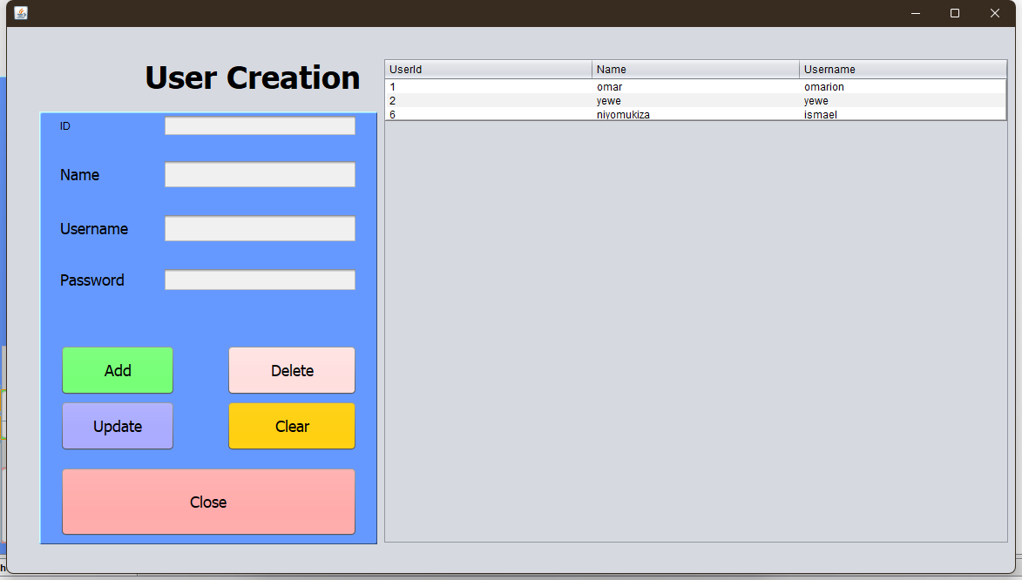
/*
* To change this license header, choose License Headers in Project Properties.
* To change this template file, choose Tools | Templates
* and open the template in the editor.
*/
package hotelmanagement;

import java.sql.Connection;
import java.sql.DriverManager;
import java.sql.PreparedStatement;
import java.sql.ResultSet;
import java.sql.ResultSetMetaData;
import java.sql.SQLException;
import java.sql.Statement;
import java.util.Vector;
import java.util.logging.Level;
import java.util.logging.Logger;
import javax.swing.JOptionPane;
import javax.swing.table.DefaultTableModel;

/**
*
* @author Omar
*/
public class user extends javax.swing.JFrame {

/**
* Creates new form user
*/
public user() {
initComponents();
connect();
load_user();
}
Connection con;
PreparedStatement pst;
DefaultTableModel d;
public void connect(){
try {
Class.forName("com.mysql.jdbc.Driver");
con=DriverManager.getConnection("jdbc:mysql://localhost:3306/hotelmanagement", "root","");
} catch (ClassNotFoundException ex) {
Logger.getLogger(room.class.getName()).log(Level.SEVERE, null, ex);
} catch (SQLException ex) {
Logger.getLogger(room.class.getName()).log(Level.SEVERE, null, ex);
}
}
public void load_user(){
int c;
try {
pst=con.prepareStatement("select * from user");
ResultSet rs=pst.executeQuery();
ResultSetMetaData rsd=rs.getMetaData();
c=rsd.getColumnCount();
d=(DefaultTableModel)jTable3.getModel();
d.setRowCount(0);
while(rs.next()){
Vector v2=new Vector();
for(int i=1;i<=c;i++){
v2.add(rs.getString("uid"));
v2.add(rs.getString("name"));
v2.add(rs.getString("username"));
//v2.add(rs.getString("amount"));
}
d.addRow(v2);
}

} catch (SQLException ex) {
Logger.getLogger(room.class.getName()).log(Level.SEVERE, null, ex);
}

}

/**
* This method is called from within the constructor to initialize the form.
* WARNING: Do NOT modify this code. The content of this method is always
* regenerated by the Form Editor.
*/
@SuppressWarnings("unchecked")
// <editor-fold defaultstate="collapsed" desc="Generated Code">
private void initComponents() {

jPanel1 = new javax.swing.JPanel();
jLabel2 = new javax.swing.JLabel();
jLabel3 = new javax.swing.JLabel();
jLabel4 = new javax.swing.JLabel();
txtname = new javax.swing.JTextField();
txtusername = new javax.swing.JTextField();
txtpassword = new javax.swing.JPasswordField();
jButton1 = new javax.swing.JButton();
jButton2 = new javax.swing.JButton();
jButton3 = new javax.swing.JButton();
jButton4 = new javax.swing.JButton();
jButton5 = new javax.swing.JButton();
jLabel5 = new javax.swing.JLabel();
txtuid = new javax.swing.JTextField();
jLabel1 = new javax.swing.JLabel();
jScrollPane1 = new javax.swing.JScrollPane();
jTable3 = new javax.swing.JTable();

setDefaultCloseOperation(javax.swing.WindowConstants.EXIT_ON_CLOSE);
setBackground(new java.awt.Color(153, 153, 153));

jPanel1.setBackground(new java.awt.Color(102, 153, 255));
jPanel1.setBorder(new javax.swing.border.SoftBevelBorder(javax.swing.border.BevelBorder.RAISED));

jLabel2.setFont(new java.awt.Font("Tahoma", 0, 18)); // NOI18N
jLabel2.setText("Name");

jLabel3.setFont(new java.awt.Font("Tahoma", 0, 18)); // NOI18N
jLabel3.setText("Username");

jLabel4.setFont(new java.awt.Font("Tahoma", 0, 18)); // NOI18N
jLabel4.setText("Password");

txtname.setBackground(new java.awt.Color(240, 240, 240));
txtname.setFont(new java.awt.Font("Tahoma", 0, 18)); // NOI18N

txtusername.setBackground(new java.awt.Color(240, 240, 240));
txtusername.setFont(new java.awt.Font("Tahoma", 0, 18)); // NOI18N

txtpassword.setBackground(new java.awt.Color(240, 240, 240));

jButton1.setBackground(new java.awt.Color(102, 255, 102));
jButton1.setFont(new java.awt.Font("Tahoma", 0, 18)); // NOI18N
jButton1.setText("Add");
jButton1.addActionListener(new java.awt.event.ActionListener() {
public void actionPerformed(java.awt.event.ActionEvent evt) {
jButton1ActionPerformed(evt);
}
});

jButton2.setBackground(new java.awt.Color(255, 204, 204));
jButton2.setFont(new java.awt.Font("Tahoma", 0, 18)); // NOI18N
jButton2.setText("Delete");
jButton2.addActionListener(new java.awt.event.ActionListener() {
public void actionPerformed(java.awt.event.ActionEvent evt) {
jButton2ActionPerformed(evt);
}
});

jButton3.setBackground(new java.awt.Color(153, 153, 255));
jButton3.setFont(new java.awt.Font("Tahoma", 0, 18)); // NOI18N
jButton3.setText("Update");
jButton3.addActionListener(new java.awt.event.ActionListener() {
public void actionPerformed(java.awt.event.ActionEvent evt) {
jButton3ActionPerformed(evt);
}
});

jButton4.setBackground(new java.awt.Color(255, 204, 0));
jButton4.setFont(new java.awt.Font("Tahoma", 0, 18)); // NOI18N
jButton4.setText("Clear");
jButton4.addActionListener(new java.awt.event.ActionListener() {
public void actionPerformed(java.awt.event.ActionEvent evt) {
jButton4ActionPerformed(evt);
}
});

jButton5.setBackground(new java.awt.Color(255, 153, 153));
jButton5.setFont(new java.awt.Font("Tahoma", 0, 18)); // NOI18N
jButton5.setText("Close");
jButton5.addActionListener(new java.awt.event.ActionListener() {
public void actionPerformed(java.awt.event.ActionEvent evt) {
jButton5ActionPerformed(evt);
}
});

jLabel5.setText("ID");

txtuid.setBackground(new java.awt.Color(240, 240, 240));
txtuid.addActionListener(new java.awt.event.ActionListener() {
public void actionPerformed(java.awt.event.ActionEvent evt) {
txtuidActionPerformed(evt);
}
});
txtuid.addKeyListener(new java.awt.event.KeyAdapter() {
public void keyPressed(java.awt.event.KeyEvent evt) {
txtuidKeyPressed(evt);
}
});

javax.swing.GroupLayout jPanel1Layout = new javax.swing.GroupLayout(jPanel1);
jPanel1.setLayout(jPanel1Layout);
jPanel1Layout.setHorizontalGroup(
jPanel1Layout.createParallelGroup(javax.swing.GroupLayout.Alignment.LEADING)
.addGroup(jPanel1Layout.createSequentialGroup()
.addGap(21, 21, 21)
.addGroup(jPanel1Layout.createParallelGroup(javax.swing.GroupLayout.Alignment.LEADING, false)
.addComponent(jButton5, javax.swing.GroupLayout.DEFAULT_SIZE, javax.swing.GroupLayout.DEFAULT_SIZE, Short.MAX_VALUE)
.addGroup(jPanel1Layout.createSequentialGroup()
.addGroup(jPanel1Layout.createParallelGroup(javax.swing.GroupLayout.Alignment.LEADING, false)
.addComponent(jButton1, javax.swing.GroupLayout.DEFAULT_SIZE, javax.swing.GroupLayout.DEFAULT_SIZE, Short.MAX_VALUE)
.addComponent(jButton3, javax.swing.GroupLayout.DEFAULT_SIZE, 132, Short.MAX_VALUE))
.addPreferredGap(javax.swing.LayoutStyle.ComponentPlacement.RELATED, 59, Short.MAX_VALUE)
.addGroup(jPanel1Layout.createParallelGroup(javax.swing.GroupLayout.Alignment.LEADING, false)
.addComponent(jButton2, javax.swing.GroupLayout.DEFAULT_SIZE, 150, Short.MAX_VALUE)
.addComponent(jButton4, javax.swing.GroupLayout.DEFAULT_SIZE, javax.swing.GroupLayout.DEFAULT_SIZE, Short.MAX_VALUE)))
.addGroup(jPanel1Layout.createSequentialGroup()
.addGroup(jPanel1Layout.createParallelGroup(javax.swing.GroupLayout.Alignment.LEADING)
.addGroup(jPanel1Layout.createParallelGroup(javax.swing.GroupLayout.Alignment.TRAILING, false)
.addComponent(jLabel3, javax.swing.GroupLayout.Alignment.LEADING, javax.swing.GroupLayout.DEFAULT_SIZE, javax.swing.GroupLayout.DEFAULT_SIZE, Short.MAX_VALUE)
.addComponent(jLabel2, javax.swing.GroupLayout.DEFAULT_SIZE, javax.swing.GroupLayout.DEFAULT_SIZE, Short.MAX_VALUE)
.addComponent(jLabel4, javax.swing.GroupLayout.DEFAULT_SIZE, javax.swing.GroupLayout.DEFAULT_SIZE, Short.MAX_VALUE))
.addComponent(jLabel5, javax.swing.GroupLayout.PREFERRED_SIZE, 78, javax.swing.GroupLayout.PREFERRED_SIZE))
.addGap(40, 40, 40)
.addGroup(jPanel1Layout.createParallelGroup(javax.swing.GroupLayout.Alignment.LEADING, false)
.addComponent(txtname)
.addComponent(txtusername)
.addComponent(txtpassword)
.addComponent(txtuid, javax.swing.GroupLayout.DEFAULT_SIZE, 223, Short.MAX_VALUE))))
.addContainerGap(20, Short.MAX_VALUE))
);
jPanel1Layout.setVerticalGroup(
jPanel1Layout.createParallelGroup(javax.swing.GroupLayout.Alignment.LEADING)
.addGroup(jPanel1Layout.createSequentialGroup()
.addGroup(jPanel1Layout.createParallelGroup(javax.swing.GroupLayout.Alignment.BASELINE)
.addComponent(jLabel5, javax.swing.GroupLayout.PREFERRED_SIZE, 26, javax.swing.GroupLayout.PREFERRED_SIZE)
.addComponent(txtuid, javax.swing.GroupLayout.PREFERRED_SIZE, 26, javax.swing.GroupLayout.PREFERRED_SIZE))
.addGap(26, 26, 26)
.addGroup(jPanel1Layout.createParallelGroup(javax.swing.GroupLayout.Alignment.BASELINE)
.addComponent(jLabel2, javax.swing.GroupLayout.PREFERRED_SIZE, 28, javax.swing.GroupLayout.PREFERRED_SIZE)
.addComponent(txtname, javax.swing.GroupLayout.PREFERRED_SIZE, javax.swing.GroupLayout.DEFAULT_SIZE, javax.swing.GroupLayout.PREFERRED_SIZE))
.addGap(28, 28, 28)
.addGroup(jPanel1Layout.createParallelGroup(javax.swing.GroupLayout.Alignment.BASELINE)
.addComponent(jLabel3, javax.swing.GroupLayout.PREFERRED_SIZE, 28, javax.swing.GroupLayout.PREFERRED_SIZE)
.addComponent(txtusername, javax.swing.GroupLayout.PREFERRED_SIZE, javax.swing.GroupLayout.DEFAULT_SIZE, javax.swing.GroupLayout.PREFERRED_SIZE))
.addGap(28, 28, 28)
.addGroup(jPanel1Layout.createParallelGroup(javax.swing.GroupLayout.Alignment.LEADING, false)
.addComponent(txtpassword)
.addComponent(jLabel4, javax.swing.GroupLayout.PREFERRED_SIZE, 28, javax.swing.GroupLayout.PREFERRED_SIZE))
.addGap(61, 61, 61)
.addGroup(jPanel1Layout.createParallelGroup(javax.swing.GroupLayout.Alignment.BASELINE)
.addComponent(jButton1, javax.swing.GroupLayout.PREFERRED_SIZE, 58, javax.swing.GroupLayout.PREFERRED_SIZE)
.addComponent(jButton2, javax.swing.GroupLayout.PREFERRED_SIZE, 58, javax.swing.GroupLayout.PREFERRED_SIZE))
.addPreferredGap(javax.swing.LayoutStyle.ComponentPlacement.RELATED)
.addGroup(jPanel1Layout.createParallelGroup(javax.swing.GroupLayout.Alignment.LEADING)
.addComponent(jButton3, javax.swing.GroupLayout.PREFERRED_SIZE, 58, javax.swing.GroupLayout.PREFERRED_SIZE)
.addComponent(jButton4, javax.swing.GroupLayout.DEFAULT_SIZE, javax.swing.GroupLayout.DEFAULT_SIZE, Short.MAX_VALUE))
.addGap(18, 18, 18)
.addComponent(jButton5, javax.swing.GroupLayout.PREFERRED_SIZE, 80, javax.swing.GroupLayout.PREFERRED_SIZE)
.addContainerGap(javax.swing.GroupLayout.DEFAULT_SIZE, Short.MAX_VALUE))
);

jLabel1.setFont(new java.awt.Font("Tahoma", 1, 36)); // NOI18N
jLabel1.setText("User Creation");

jTable3.setBorder(javax.swing.BorderFactory.createBevelBorder(javax.swing.border.BevelBorder.RAISED));
jTable3.setModel(new javax.swing.table.DefaultTableModel(
new Object [][] {

},
new String [] {
"UserId", "Name", "Username"
}
) {
Class[] types = new Class [] {
java.lang.String.class, java.lang.Object.class, java.lang.Object.class
};

public Class getColumnClass(int columnIndex) {
return types [columnIndex];
}
});
jTable3.addMouseListener(new java.awt.event.MouseAdapter() {
public void mouseClicked(java.awt.event.MouseEvent evt) {
jTable3MouseClicked(evt);
}
});
jScrollPane1.setViewportView(jTable3);

javax.swing.GroupLayout layout = new javax.swing.GroupLayout(getContentPane());
getContentPane().setLayout(layout);
layout.setHorizontalGroup(
layout.createParallelGroup(javax.swing.GroupLayout.Alignment.LEADING)
.addGroup(layout.createSequentialGroup()
.addGroup(layout.createParallelGroup(javax.swing.GroupLayout.Alignment.LEADING)
.addGroup(layout.createSequentialGroup()
.addGap(158, 158, 158)
.addComponent(jLabel1))
.addGroup(layout.createSequentialGroup()
.addGap(37, 37, 37)
.addComponent(jPanel1, javax.swing.GroupLayout.PREFERRED_SIZE, javax.swing.GroupLayout.DEFAULT_SIZE, javax.swing.GroupLayout.PREFERRED_SIZE)))
.addPreferredGap(javax.swing.LayoutStyle.ComponentPlacement.RELATED)
.addComponent(jScrollPane1, javax.swing.GroupLayout.DEFAULT_SIZE, 720, Short.MAX_VALUE)
.addContainerGap())
);
layout.setVerticalGroup(
layout.createParallelGroup(javax.swing.GroupLayout.Alignment.LEADING)
.addGroup(layout.createSequentialGroup()
.addGap(35, 35, 35)
.addGroup(layout.createParallelGroup(javax.swing.GroupLayout.Alignment.LEADING, false)
.addComponent(jScrollPane1)
.addGroup(layout.createSequentialGroup()
.addComponent(jLabel1)
.addGap(18, 18, 18)
.addComponent(jPanel1, javax.swing.GroupLayout.PREFERRED_SIZE, javax.swing.GroupLayout.DEFAULT_SIZE, javax.swing.GroupLayout.PREFERRED_SIZE)))
.addContainerGap(33, Short.MAX_VALUE))
);

pack();
setLocationRelativeTo(null);
}// </editor-fold>

private void jButton1ActionPerformed(java.awt.event.ActionEvent evt) {
// TODO add your handling code here:
String name=txtname.getText();
String username=txtusername.getText();
String password=txtpassword.getText();
try {
pst=con.prepareStatement("insert into user(name,username,password) values (?,?,?)");
pst.setString(1, name);
pst.setString(2, username);
pst.setString(3, password);
pst.executeUpdate();
JOptionPane.showMessageDialog(null,"User Added");
txtname.setText("");
txtusername.setText("");
txtpassword.setText("");
txtname.requestFocus();
load_user();
} catch (SQLException ex) {
Logger.getLogger(room.class.getName()).log(Level.SEVERE, null, ex);
}

}

private void jButton5ActionPerformed(java.awt.event.ActionEvent evt) {
// TODO add your handling code here:
this.setVisible(false);
}

private void jButton3ActionPerformed(java.awt.event.ActionEvent evt) {
// TODO add your handling code here:
String id=txtuid.getText();
String name=txtname.getText();
String username=txtusername.getText();
String password=txtpassword.getText();
try {
pst=con.prepareStatement("update user set name=?,username=?,password=? where uid= ?");
pst.setString(1, name);
pst.setString(2, username);
pst.setString(3, password);
pst.setString(4, id);
//pst.setString(4, id);
pst.executeUpdate();
JOptionPane.showMessageDialog(null,"User Edited");
txtname.setText("");
txtusername.setText("");
txtpassword.setText("");
txtname.requestFocus();
//autoID();
load_user();
jButton1.setEnabled(false);
} catch (SQLException ex) {
Logger.getLogger(room.class.getName()).log(Level.SEVERE, null, ex);
}
}

private void jTable3MouseClicked(java.awt.event.MouseEvent evt) {
// TODO add your handling code here:
d=(DefaultTableModel)jTable3.getModel();
int selectIndex=jTable3.getSelectedRow();
txtuid.setText(d.getValueAt(selectIndex, 0).toString());
txtname.setText(d.getValueAt(selectIndex, 1).toString());
txtusername.setText(d.getValueAt(selectIndex, 2).toString());
jButton1.setEnabled(false);

}

private void jButton4ActionPerformed(java.awt.event.ActionEvent evt) {
// TODO add your handling code here:
txtuid.setText("");
txtname.setText("");
txtusername.setText("");
txtpassword.setText("");
load_user();
jButton1.setEnabled(true);
}

private void jButton2ActionPerformed(java.awt.event.ActionEvent evt) {
// TODO add your handling code here:
String userid=txtuid.getText();

try {
pst=con.prepareStatement("delete from user where uid=?");
pst.setString(1, userid);
pst.executeUpdate();
JOptionPane.showMessageDialog(null,"User Deleted");
txtuid.setText("");
txtname.setText("");
txtusername.setText("");
txtpassword.setText("");
//autoID();
load_user();
jButton1.setEnabled(false);
} catch (SQLException ex) {
Logger.getLogger(room.class.getName()).log(Level.SEVERE, null, ex);
}
}

private void txtuidKeyPressed(java.awt.event.KeyEvent evt) {
// TODO add your handling code here:
jButton1.setVisible(false);
jButton3.setVisible(false);
}

private void txtuidActionPerformed(java.awt.event.ActionEvent evt) {
// TODO add your handling code here:
jButton1.setVisible(false);
jButton3.setVisible(false);
}

/**
* @param args the command line arguments
*/
public static void main(String args[]) {
/* Set the Nimbus look and feel */
//<editor-fold defaultstate="collapsed" desc=" Look and feel setting code (optional) ">
/* If Nimbus (introduced in Java SE 6) is not available, stay with the default look and feel.
* For details see http://download.oracle.com/javase/tutorial/uiswing/lookandfeel/plaf.html
*/
try {
for (javax.swing.UIManager.LookAndFeelInfo info : javax.swing.UIManager.getInstalledLookAndFeels()) {
if ("Nimbus".equals(info.getName())) {
javax.swing.UIManager.setLookAndFeel(info.getClassName());
break;
}
}
} catch (ClassNotFoundException ex) {
java.util.logging.Logger.getLogger(user.class.getName()).log(java.util.logging.Level.SEVERE, null, ex);
} catch (InstantiationException ex) {
java.util.logging.Logger.getLogger(user.class.getName()).log(java.util.logging.Level.SEVERE, null, ex);
} catch (IllegalAccessException ex) {
java.util.logging.Logger.getLogger(user.class.getName()).log(java.util.logging.Level.SEVERE, null, ex);
} catch (javax.swing.UnsupportedLookAndFeelException ex) {
java.util.logging.Logger.getLogger(user.class.getName()).log(java.util.logging.Level.SEVERE, null, ex);
}
//</editor-fold>

/* Create and display the form */
java.awt.EventQueue.invokeLater(new Runnable() {
public void run() {
new user().setVisible(true);
}
});
}

// Variables declaration - do not modify
private javax.swing.JButton jButton1;
private javax.swing.JButton jButton2;
private javax.swing.JButton jButton3;
private javax.swing.JButton jButton4;
private javax.swing.JButton jButton5;
private javax.swing.JLabel jLabel1;
private javax.swing.JLabel jLabel2;
private javax.swing.JLabel jLabel3;
private javax.swing.JLabel jLabel4;
private javax.swing.JLabel jLabel5;
private javax.swing.JPanel jPanel1;
private javax.swing.JScrollPane jScrollPane1;
private javax.swing.JTable jTable3;
private javax.swing.JTextField txtname;
private javax.swing.JPasswordField txtpassword;
private javax.swing.JTextField txtuid;
private javax.swing.JTextField txtusername;
// End of variables declaration
}

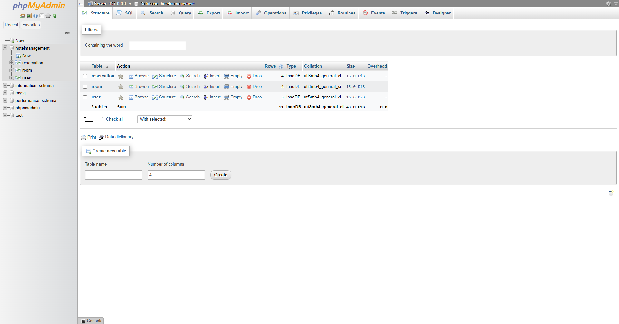

4.Testing

“In this Section, Students to show the way this stage was conducted. Ensuring that everything works as expected. Which defects and bugs you found, and how did you fixed them to ensure that the product meets the original specifications.”

When building a hotel management system in Java, there are several types of bugs that may be encountered. Some common bugs that may be found include:

Syntax errors: These are errors that occur when the code is not written correctly and the Java compiler is unable to understand it. These errors can be fixed by reviewing the code and correcting any syntax errors.

Logical errors: These are errors that occur when the code is written correctly but the logic is not correct. For example, a function to calculate the total bill may be incorrect. Logical errors can be fixed by reviewing the code and identifying the incorrect logic, then correcting it.

Runtime errors: These are errors that occur when the code is executed and there is an issue with the runtime environment, such as a missing library or class. These errors can be fixed by reviewing the code and identifying the missing resource, then adding it to the environment.

Concurrency errors: These are errors that occur when multiple threads are accessing the same resource simultaneously, such as a database or file, and there is a conflict or race condition. These errors can be fixed by implementing proper synchronization techniques, such as using locks or semaphores, to control access to the shared resource.

Input validation errors: These are errors that occur when the system does not properly validate user input, such as allowing a user to enter negative numbers for a room rate. These errors can be fixed by implementing proper input validation checks in the code.

Security errors: These are errors that occur due to lack of proper security measures, such as not properly encrypting sensitive data. These errors can be fixed by implementing proper security measures, such as using encryption and secure authentication methods.

User interface errors: These are errors that occur in the user interface, such as buttons not working as intended or incorrect labels being displayed. These errors can be fixed by reviewing the user interface design and ensuring that it is functioning as intended.

It's important to have a thorough testing process in place to catch these bugs and fix them before the final release of the software.

5.Deployment

“In this Section, Students have to describe how, installation, testing, deployment, and performance monitoring were conducted in their own respective laptop or desktop. “

We have deployed our java project using pc software application called NetBeans IDE, the way you can Install it, is having the application we deployed and then run it as well.

The testing was great thing, because we did get some difficulty about connect the application with database after deploying our application. But the good thing we found is the error was in our xampp database server as you can see.
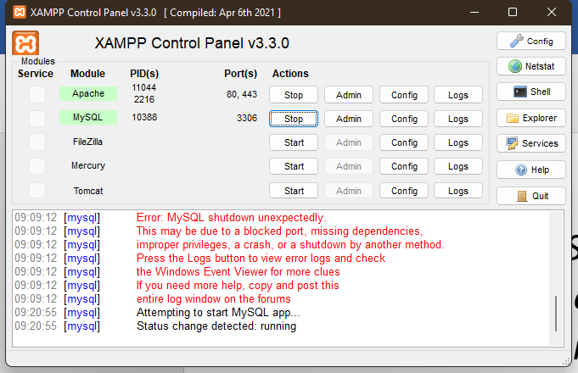
Mysql shutdown unexpectedly and I went on the internet to find help, and then fixed it, as you can see it below.
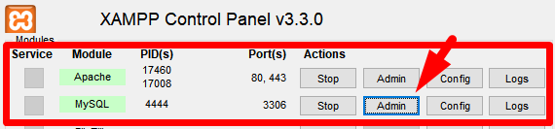

We did an ongoing performance monitoring daily, so that we can make sure that every error and bugs are well removed and now we have a well working pc application, if you want to use HOTEL MANAGEMNT SYSTEM, you just have to run it and run your business

